1. **Variables** :

* **Introduction of Variable :**
* Variables are identifiers that’s value can be changed upon need.
* Variable follows same naming convention as followed by any other identifier. Variables are case sensitive, that means Firstname and firstname are different variables.
* Javascript has six variable types : Object, Number , String, Boolean, null, undefined. Object includes arrays, functions, and other ordinary objects. Numbers may include integers, floating point numbers, NaN, Infinity and -Infinity. typeof operator can be used to get type of the object and instanceof operator returns true if the given object is instance of given type.
* There are various types of operation that can be performed on given variables like bitwise, arithmetic, assignment, string, and comparison, logical and type operations.
* **Programming Question :**

Display data types of defined various student related terms variables upon clicking respected buttons.

* **Code :**

<!DOCTYPE html>

<html>

<head>

<meta charset=*"ISO-8859-1"*>

<meta name=*"Author"* content=*"Vishweshkumar Patel"*>

<meta name=*"Description"* content=*"Homework_1_CMPE_273 : JavaScript Variables"*>

<meta name=*"keyword"* content=*" HTML, CSS, JavaScript, Variables"*>

<meta name=*"last modified"* content=*"Sept 7,2017"*>

<meta name=*"viewport"* content=*"width=device-width, initial-scale=1.0"*>

<meta http-equiv=*"refresh"* content=*"120"*>

<title> JavaScript Variables </title>

<style type=*"text/css"*>

**header,** **footer,** **section,** **article**{

display: *block*;

}

**section**{

text-align: *center*;

}

</style>

<script type=*"text/javascript"*>

**var** subject = {name: "CMPE 273", professor: "Simon Shim"} ;

**var** addCode;

**var** future = 1/"a";

**var** name = "vishwesh";

**var** age = 21;

**var** func = **function** getAge(){};

**var** subjects = ["CMPE 202","CMPE 272","CMPE 273"];

**var** goodGrades = **true**;

**function** myFunction() {

**var** target = event.target || event.srcElement;

**var** id = target.id ;

**var** sid = id.toString();

**var** type = "";

**switch**(sid){

**case** "subject":

type = **typeof** subject;

**break**;

**case** "addcode":

type = **typeof** addCode;

**break**;

**case** "future":

type = **typeof** future;

**break**;

**case** "name":

type = **typeof** name;

**break**;

**case** "age":

type = **typeof** age;

**break**;

**case** "func":

type = **typeof** func;

**break**;

**case** "subjects":

type = **typeof** subjects;

**break**;

**case** "goodGrades":

type = **typeof** goodGrades;

**break**;

**default**:

}

document.getElementById(sid+"Type").innerHTML = type + " <br/> " ;

**var** blck = document.getElementById(sid+"Type") ;

**if** (blck.style.display === 'none') {

blck.style.display = 'block';

} **else** {

blck.style.display = 'none';

}

}

</script>

</head>

<body>

<header>

<h1>JavaScript Variables</h1>

</header>

<section>

<article>

<h3> Click on following student related terms to get their data type : </h3>

String : <button id=*"subject"* onclick="myFunction()"> subject </button>

<div id=*"subjectType"*> </div> <br/>

Undefined : <button id=*"addcode"* onclick="myFunction()"> Add Code </button>

<div id=*"addcodeType"*> </div> <br/>

NaN : <button id=*"future"* onclick="myFunction()"> Future </button>

<div id=*"futureType"*> </div> <br/>

String : <button id=*"name"* onclick="myFunction()"> Name </button>

<div id=*"nameType"*> </div> <br/>

Number : <button id=*"age"* onclick="myFunction()"> Age </button>

<div id=*"ageType"*> </div> <br/>

Function : <button id=*"func"* onclick="myFunction()"> Get Age Function </button>

<div id=*"funcType"*> </div> <br/>

Array : <button id=*"subjects"* onclick="myFunction()"> Subjects </button>

<div id=*"subjectsType"*> </div> <br/>

Boolean : <button id=*"goodGrades"* onclick="myFunction()"> Good Grades </button>

<div id=*"goodGradesType"*> </div> <br/>

</article>

</section>

<footer>

<h3> Created By : Vishweshkumar Patel </h3>

<h3> Contact @ vishweshkumar.patel@sjsu.edu </h3>

</footer>

</body>

</html>

* **Output’s Screenshot :**

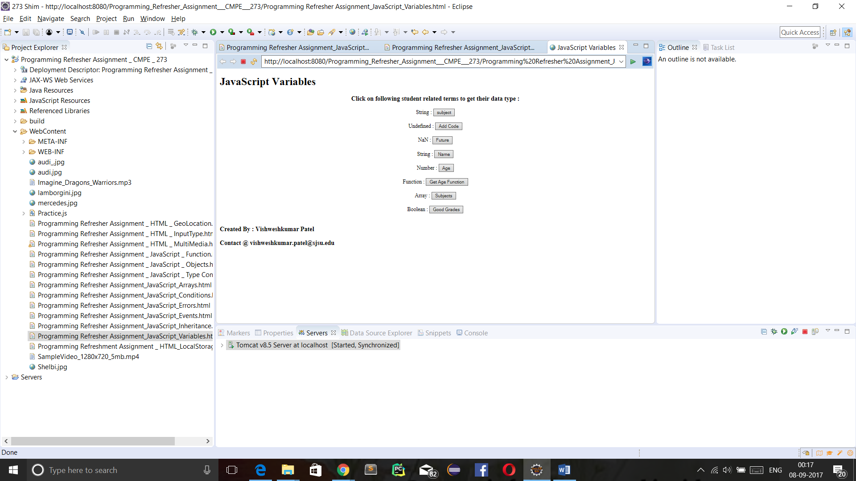

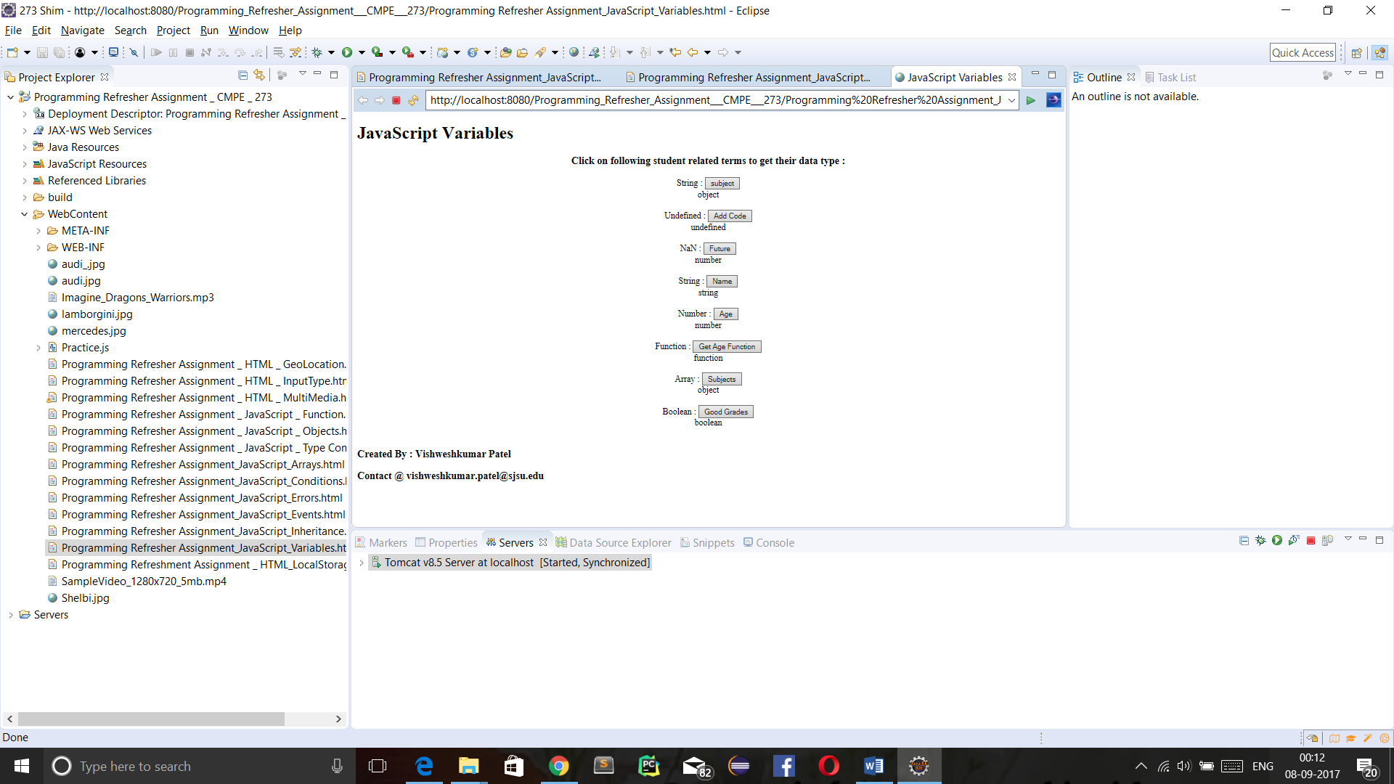

1. **Objects** :

* **Introduction of Objects :**

JavaScript objects are used to define properties and behaviour of an entity. Object variable are used to define properties and methods are used to define behaviour of associated entity.

* **Programming Question :**

Design a webpage that shows details of cars : type, model, horsepower, maximum retail price and image of car. Use Javascript object to store details.

* **Code :**

<!DOCTYPE html>

<html>

<head>

<meta charset=*"ISO-8859-1"*>

<meta name=*"Author"* content=*"Vishweshkumar Patel"*>

<meta name=*"Description"* content=*"Homework_1_CMPE_273 : JavaScript Objects"*>

<meta name=*"keyword"* content=*" HTML, CSS, JavaScript, JavaScript Objects"*>

<meta name=*"last modified"* content=*"Sept 3,2017"*>

<meta name=*"viewport"* content=*"width=device-width; initial-scale=1.0"*>

<meta http-equiv=*"refresh"* content=*"120"*>

<title> JavaScript Objects </title>

<style type=*"text/css"*>

**header,** **footer,** **section,** **article**{

display: *block*;

}

**section**{

text-align: *center*;

}

</style>

<script type=*"text/javascript"*>

**function** loadDetails(){

**var** audi = {type:"Audi", model:"R8", color:"Black" , MSRP: "From $162,900" , Horsepower: "540 to 610 hp" , image_src: "audi_.jpg"};

**var** shelbi = {type:"Ford", model:"GT350", color:"Black" , MSRP: "From $54,845" , Horsepower: "526 hp", image_src: "Shelbi.jpg" };

**var** mercedes = {type:"Mercedes", model:"SLS AMG", color:"Ash" , Horsepower: "583 hp" , MSRP: "From $200,00" , image_src: "mercedes.jpg"};

**var** lamborgini = {type:"Lamborgini", model:"Aventador", color:"Black" ,MSRP: "From $399,500" , Horsepower: "691 to 740 hp", image_src: "lamborgini.jpg"};

**var** target = event.target || event.srcElement;

**var** id = target.id;

**var** c = id.toString();

**switch**(c){

**case** "audi" :

**var** car = audi;

**break**;

**case** "Shelbi" :

**var** car = shelbi;

**break**;

**case** "mercedes" :

**var** car = mercedes;

**break**;

**case** "lamborgini" :

**var** car = lamborgini;

**break**;

**default**:

}

document.getElementById("car_detail").innerHTML = '<br/> <img align="center" src='+ car.image_src +' alt="!! Image not available. !!" width="800px" height="500px" /> <br/> <br/> <br/> '

+ ' Car Type : <input type="text" name="type" value="' + car.type + '" disabled/> <br/> <br/> '

+ ' Car Model : <input type="text" name="model" value="' + car.model + '" disabled/> <br/> <br/> '

+ ' Car Color : <input type="text" name="color" value="' + car.color + '" disabled/> <br/> <br/> '

+ ' Car MSRP : <input type="text" name="MSRP" value="' + car.MSRP + '" disabled/> <br/> <br/> '

+ ' Car HorsePower : <input type="text" name="Horsepower" value="' + car.Horsepower + '" disabled/> <br/> <br/> ' ;

}

</script>

</head>

<body>

<header>

<h1 style="text-align: *center*"> JavaScript : Object </h1>

</header>

<br/>

<section>

<article>

<h3> Choose a Car to know its Specifications : </h3>

<input type=*"radio"* name=*"option"* id=*"audi"* onchange=*"loadDetails()"*/> Audi <br/>

<input type=*"radio"* name=*"option"* id=*"Shelbi"* onchange=*"loadDetails()"*/> Shelbi <br/>

<input type=*"radio"* name=*"option"* id=*"mercedes"* onchange=*"loadDetails()"*/> Mercedes <br/>

<input type=*"radio"* name=*"option"* id=*"lamborgini"* onchange=*"loadDetails()"*/> Lamborgini <br/>

</article>

<article>

<br/>

<div id=*"car_detail"*> </div>

</article>

</section>

<footer>

</footer>

</body>

</html>

* **Output’s Screenshot :**

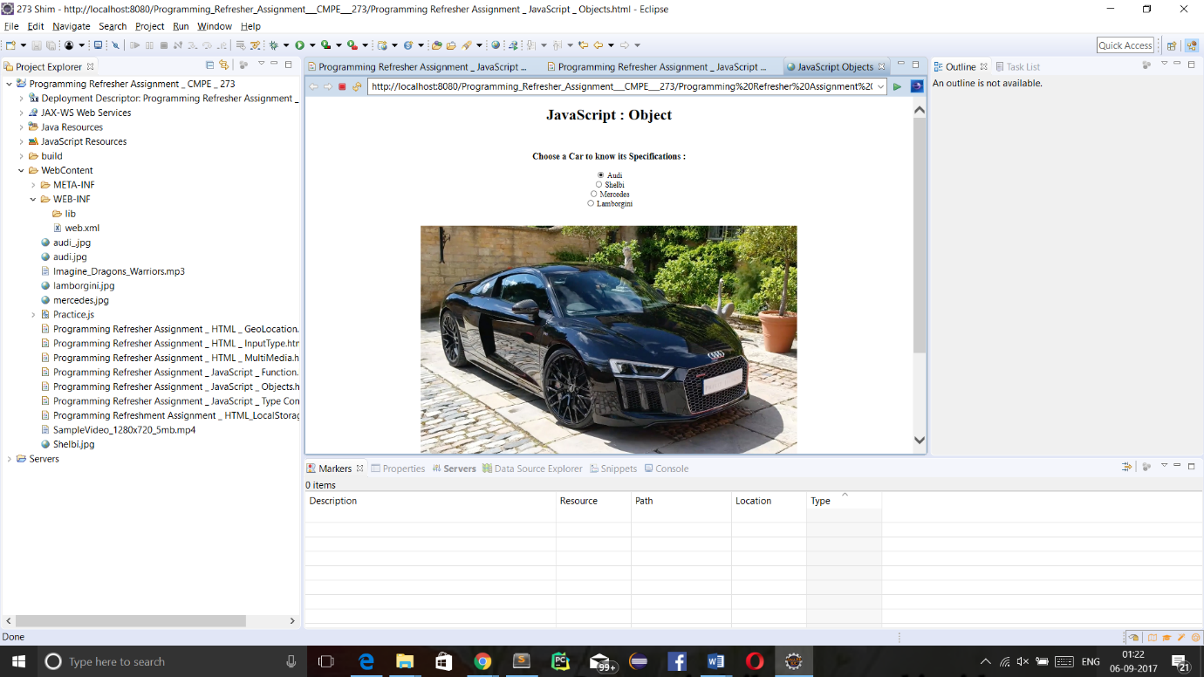

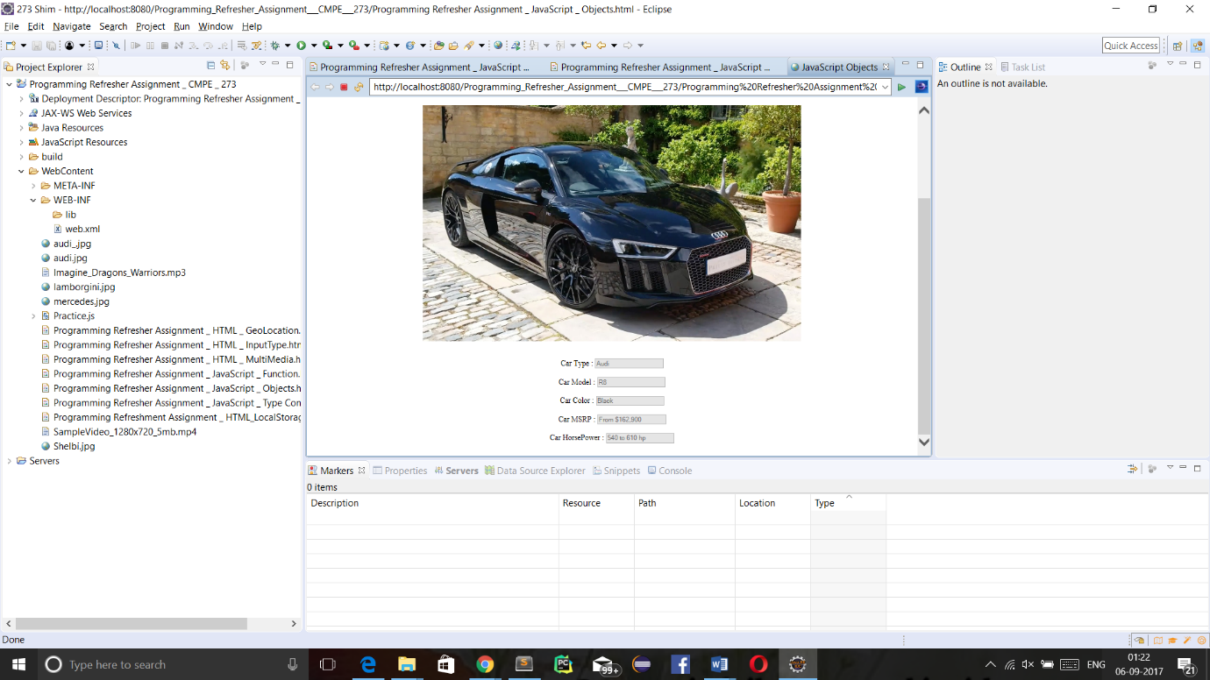

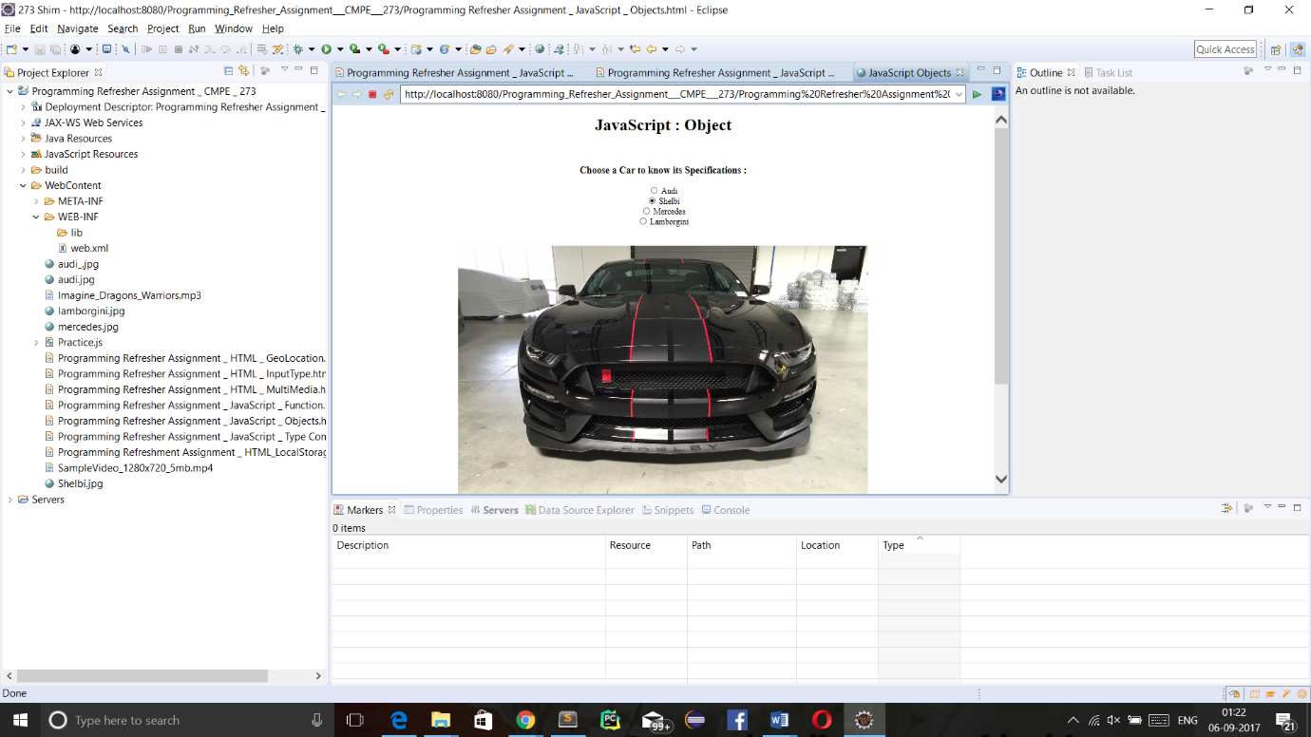

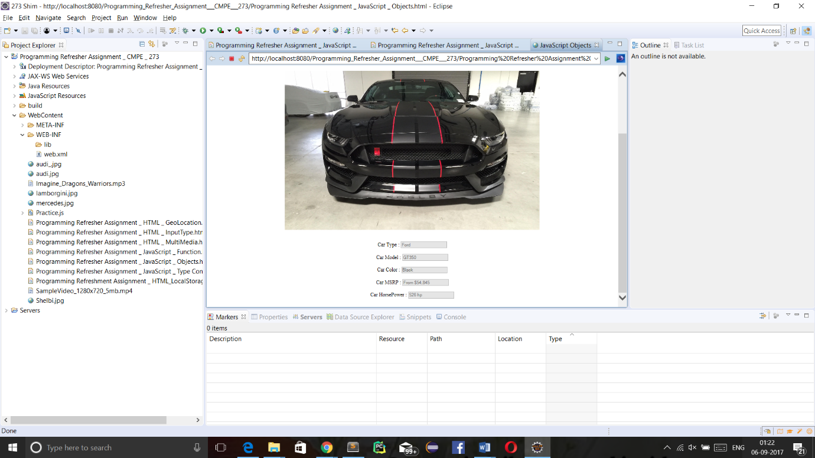

1. **Functions** :

* **Introduction of Functions :**
* Functions are modules that performs particular tasks and may return result to calling element.
* Function can be defined using following syntax :

function function_name(parameter1, parameter2,..) {

// task

return result;

}

* “function” is keyword, “function_name” is name of function. “parameter1,parameter2,…” are parameters that are passed to called function by calling element. “return” statement is not a requirement but when function is called by javascript, statement function may return produced result.
* Function can be invoked in there ways: upon event occurrence or invocation or automatic invocation.

* **Programming Question :**

Design a webpage which contains two text box, one text box takes hexadecimal representation of colour as input and second one takes alphabetical representation of colour as input and based on those input change background colour of webpage.

* **Code :**

<!DOCTYPE html>

<html>

<head>

<meta charset=*"ISO-8859-1"*>

<meta name=*"Author"* content=*"Vishweshkumar Patel"*>

<meta name=*"Description"* content=*"Homework_1_CMPE_273 : JavaScript Function"*>

<meta name=*"keyword"* content=*" HTML, CSS, JavaScript, Function"*>

<meta name=*"last modified"* content=*"Sept 3,2017"*>

<meta name=*"viewport"* content=*"width=device-width, initial-scale=1.0"*>

<meta http-equiv=*"refresh"* content=*"120"*>

<title> JavaScript Function </title>

<style type=*"text/css"*>

**header,** **footer,** **section,** **article**{

display: *block*;

}

</style>

<script type=*"text/javascript"*>

**function** changeColorHex(){

**var** cvalue = document.getElementById("colorHex").value ;

**if** (cvalue.length == 6){

document.getElementById("Body").style.backgroundColor="#"+document.getElementById("colorHex").value ;

}

**else**{

invalidHexEntry();

}

}

**function** changeColorName(){

**var** match = /[A-Z]|[a-z]/ ;

**if** (match.test(document.getElementById("colorName").value)){

document.getElementById("Body").style.backgroundColor= document.getElementById("colorName").value ;

}

**else**{

invalidNameEntry();

}

}

**function** invalidHexEntry(){

alert(" ***** !! Wrong Entry !! ***** \n ** Only Hexadecimal number of six digits are allowed. **");

}

**function** invalidNameEntry(){

alert("***** !! Wrong Entry !! ***** \n ** Only Alphabets are allowed. **");

}

</script>

</head>

<body id=*"Body"*>

<header>

<h1 style="text-align: *center*;"> JavaScript : Functions </h1>

</header>

<section>

<article>

<h3 style="text-align: *center*;" > Enter six digit Hexadecimal code to change background of Web page : </h3>

<input type=*"text"* name=*"bgColor"* id=*"colorHex"* /> <br/> <br/>

<button onclick="changeColorHex()"> !! Click Me !! </button>

</article>

<article>

<h3 style="text-align: *center*;" > Enter color name to change background of Web page : </h3>

<input type=*"text"* name=*"bgColor"* id=*"colorName"* /> <br/> <br/>

<button onclick="changeColorName()"> !! Click Me !! </button>

</article>

</section>

<footer>

<h2> Created By : Vishweshkumar Patel </h2>

<h2> Contact @ vishweshkumar.patel@sjsu.edu </h2>

</footer>

</body>

</html>

* **Output’s Screenshot :**

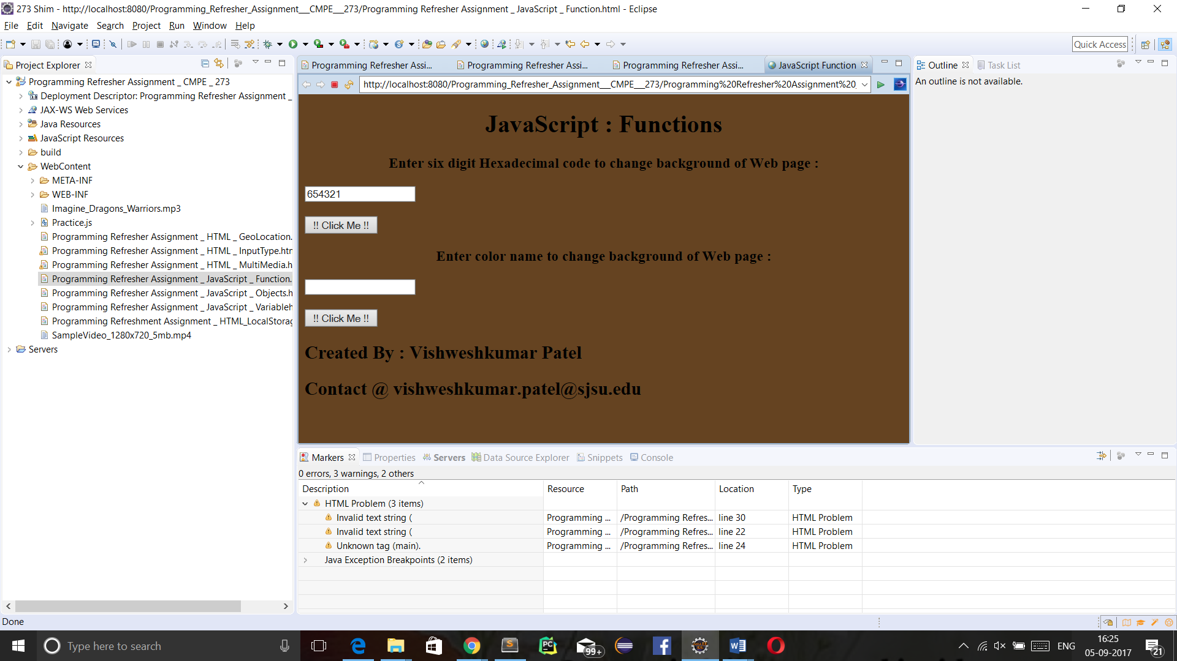

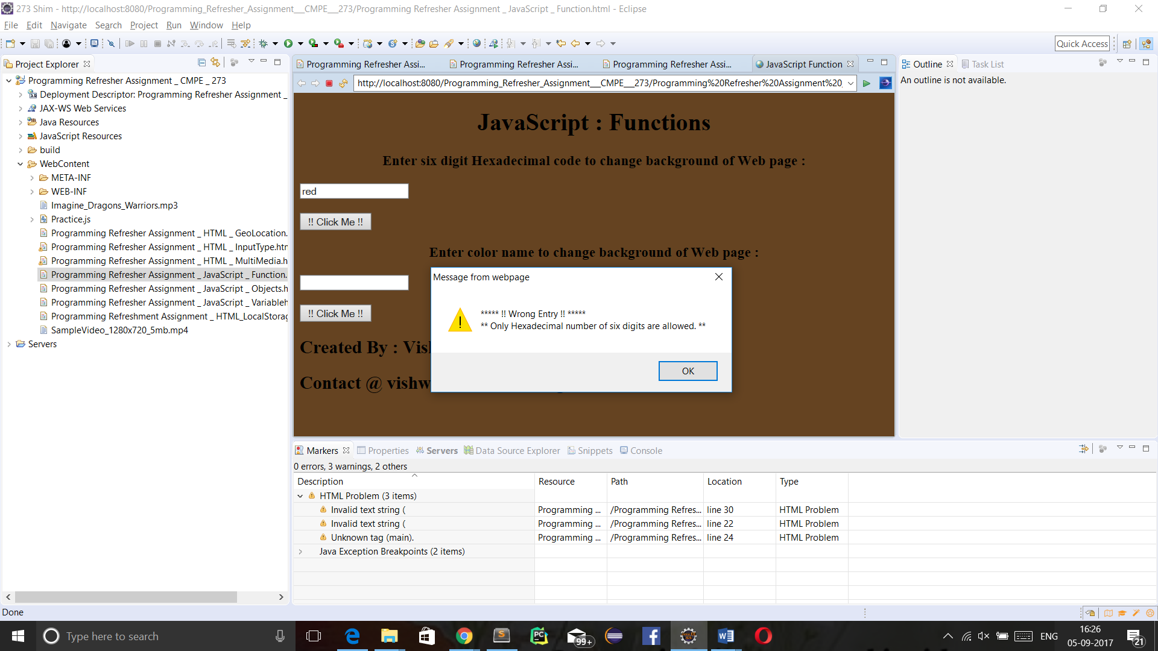

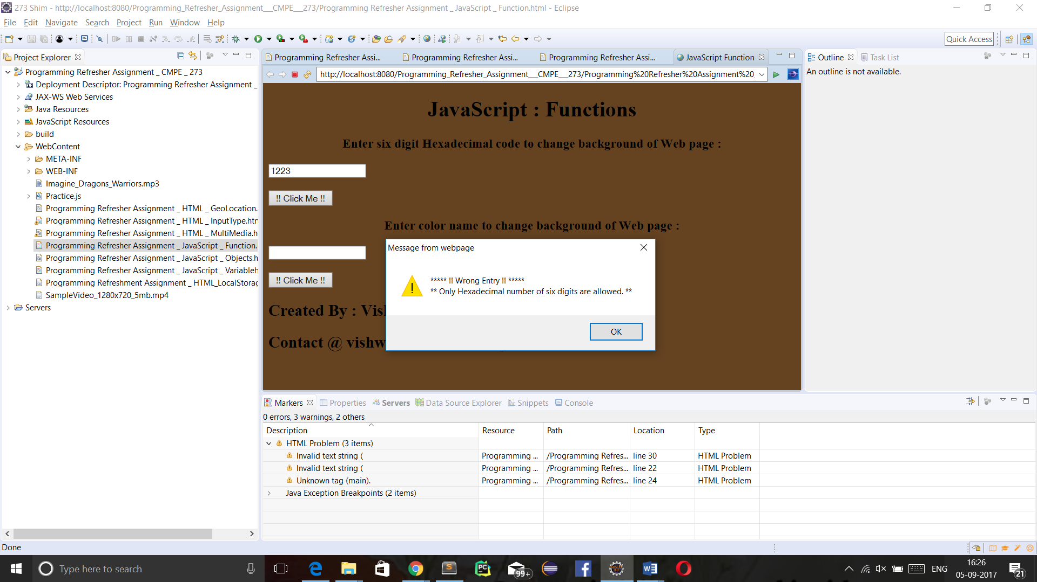

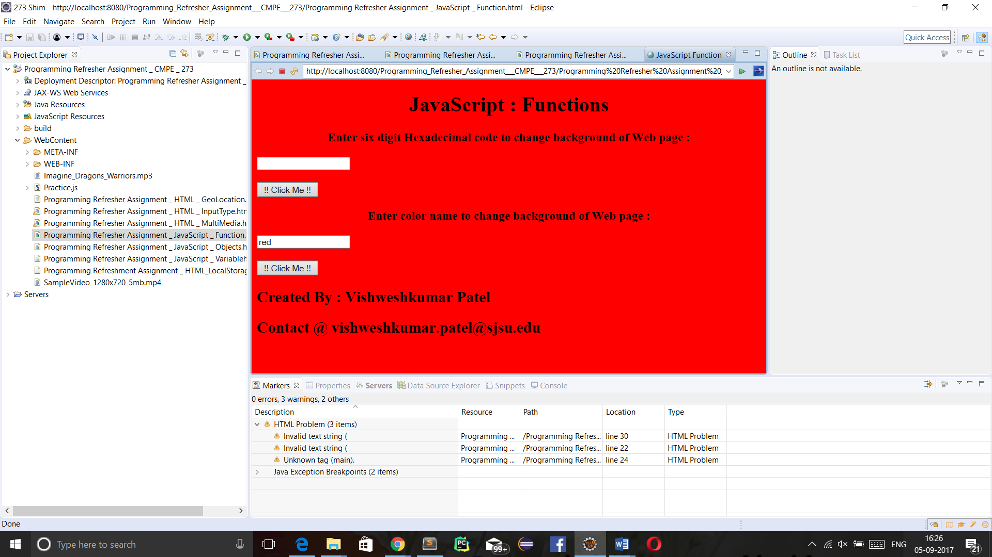

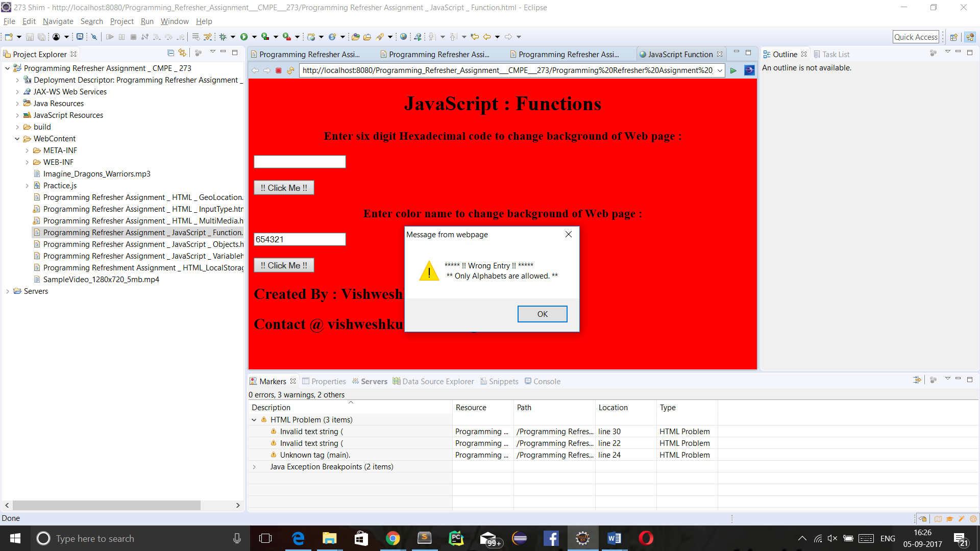

1. **Events** :

* **Introduction of Events:**

Javascript events are functions that changes behaviour of some component of HTML page upon some change in other or same component. There are various kinds of Events : Mouse related events, Keyboard related event,etc.

* **Programming Question :**

Design a static webpage that has a certain area where upon moving the mouse background colour of that area changes and upon moving in or out colour of whole surrounded changes.

* **Code :**

<!DOCTYPE html>

<html>

<head>

<meta charset=*"ISO-8859-1"*>

<meta name=*"Author"* content=*"Vishweshkumar Patel"*>

<meta name=*"Description"* content=*"Homework_1_CMPE_273 : JavaScript Events"*>

<meta name=*"keyword"* content=*" HTML, CSS, JavaScript, Events"*>

<meta name=*"last modified"* content=*"Sept 6,2017"*>

<meta name=*"viewport"* content=*"width=device-width, initial-scale=1.0"*>

<meta http-equiv=*"refresh"* content=*"120"*>

<title> JavaScript Events </title>

<style type=*"text/css"*>

**header,** **footer,** **section,** **article**{

display: *block*;

}

**section**{

text-apgn: *center*;

}

</style>

</head>

<body style="text-apgn:*center*;" >

<header>

<h1>JavaScript Events</h1>

</header>

<section id=*"section"* style="height: *900px*; width: *400px*; text-align: *center*; vertical-align: *middle*;">

<article>

<h3> This page is enabled to perform following Events : </h3>

<p style="height: *250px*; width: *250px*; text-align: *center*; vertical-align: *middle*;" id=*"On Mouse Move"* onmousemove="OnMouseMove()"> On Mouse Move </p> <br/>

<p style="height: *250px*; width: *250px*; text-align: *center*; vertical-align: *middle*;" id=*"On Mouse Enter"* onmouseenter=*"OnMouseEnter()"*> On Mouse Enter </p> <br/>

<p style="height: *250px*; width: *250px*; text-align: *center*; vertical-align: *middle*;" id=*"On Mouse Out"* onmouseout="OnMouseOut()"> On Mouse Out </p> <br/>

</article>

<script type=*"text/javascript"*>

**var** i = 0;

**function** OnMouseEnter()

{

document.getElementById("section").style.backgroundColor = "green";

}

**function** OnMouseOut()

{

document.getElementById("section").style.backgroundColor = "blue";

}

**function** OnMouseMove()

{

**if** (i%5==0){

document.getElementById("On Mouse Move").style.backgroundColor = "red";

document.getElementById("On Mouse Move").innerHTML = "Red Color";

i++;

}

**else** **if** (i%5==1){

document.getElementById("On Mouse Move").style.backgroundColor = "blue";

document.getElementById("On Mouse Move").innerHTML = "Blue Color";

i++;

}

**else** **if**(i%5==2){

document.getElementById("On Mouse Move").style.backgroundColor = "yellow";

document.getElementById("On Mouse Move").innerHTML = "Yellow Color";

i++;

}

**else** **if**(i%5==3){

document.getElementById("On Mouse Move").style.backgroundColor = "purple";

document.getElementById("On Mouse Move").innerHTML = "Purple Color";

i++;

}

**else** **if**(i%5==4){

document.getElementById("On Mouse Move").style.backgroundColor = "black";

document.getElementById("On Mouse Move").innerHTML = "Black Color";

document.getElementById("On Mouse Move").style.color = "black";

i++;

}

}

</script>

</section>

<footer>

<h3> Created By : Vishweshkumar Patel </h3>

<h3> Contact @ vishweshkumar.patel@sjsu.edu </h3>

</footer>

</body>

</html>

* **Output’s Screenshot :**

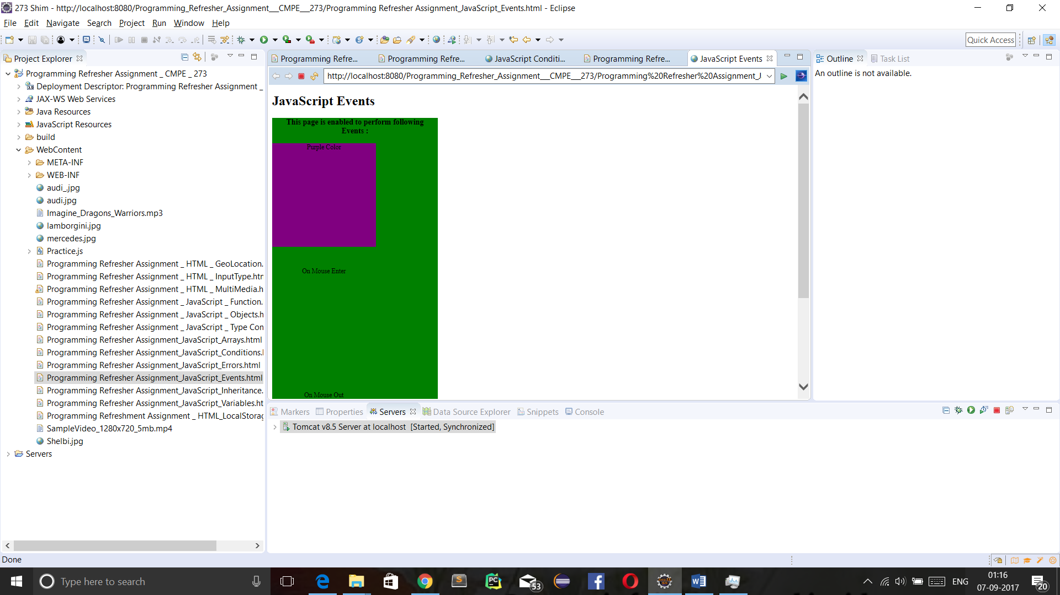

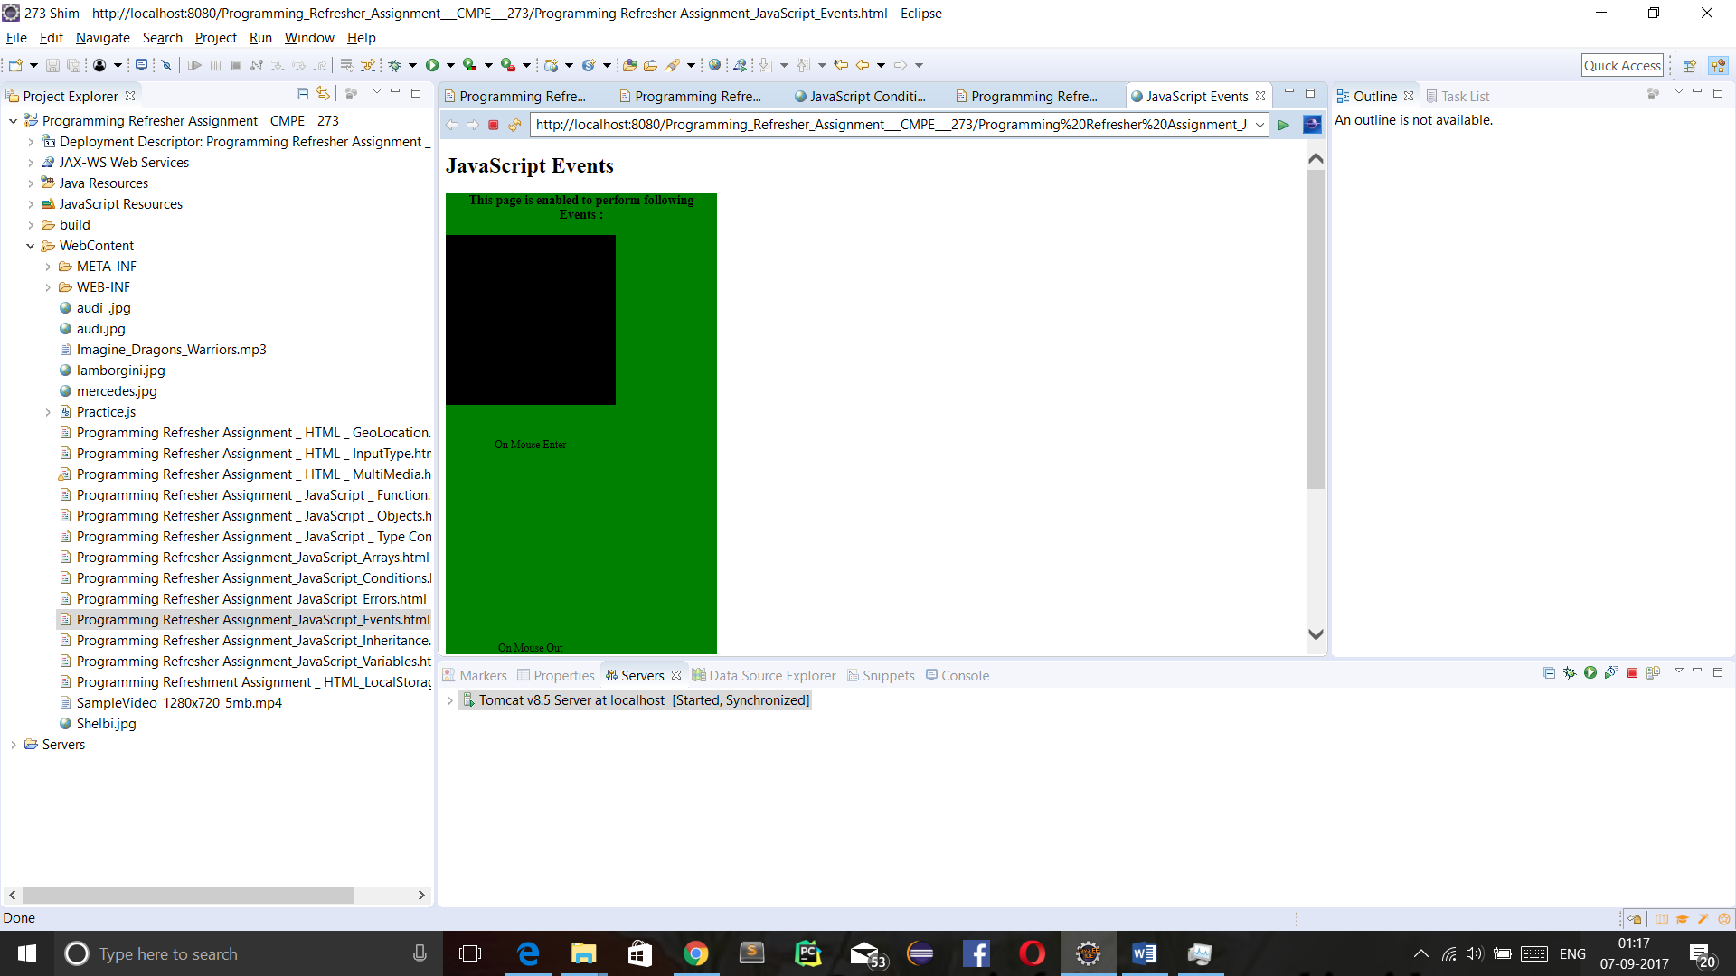

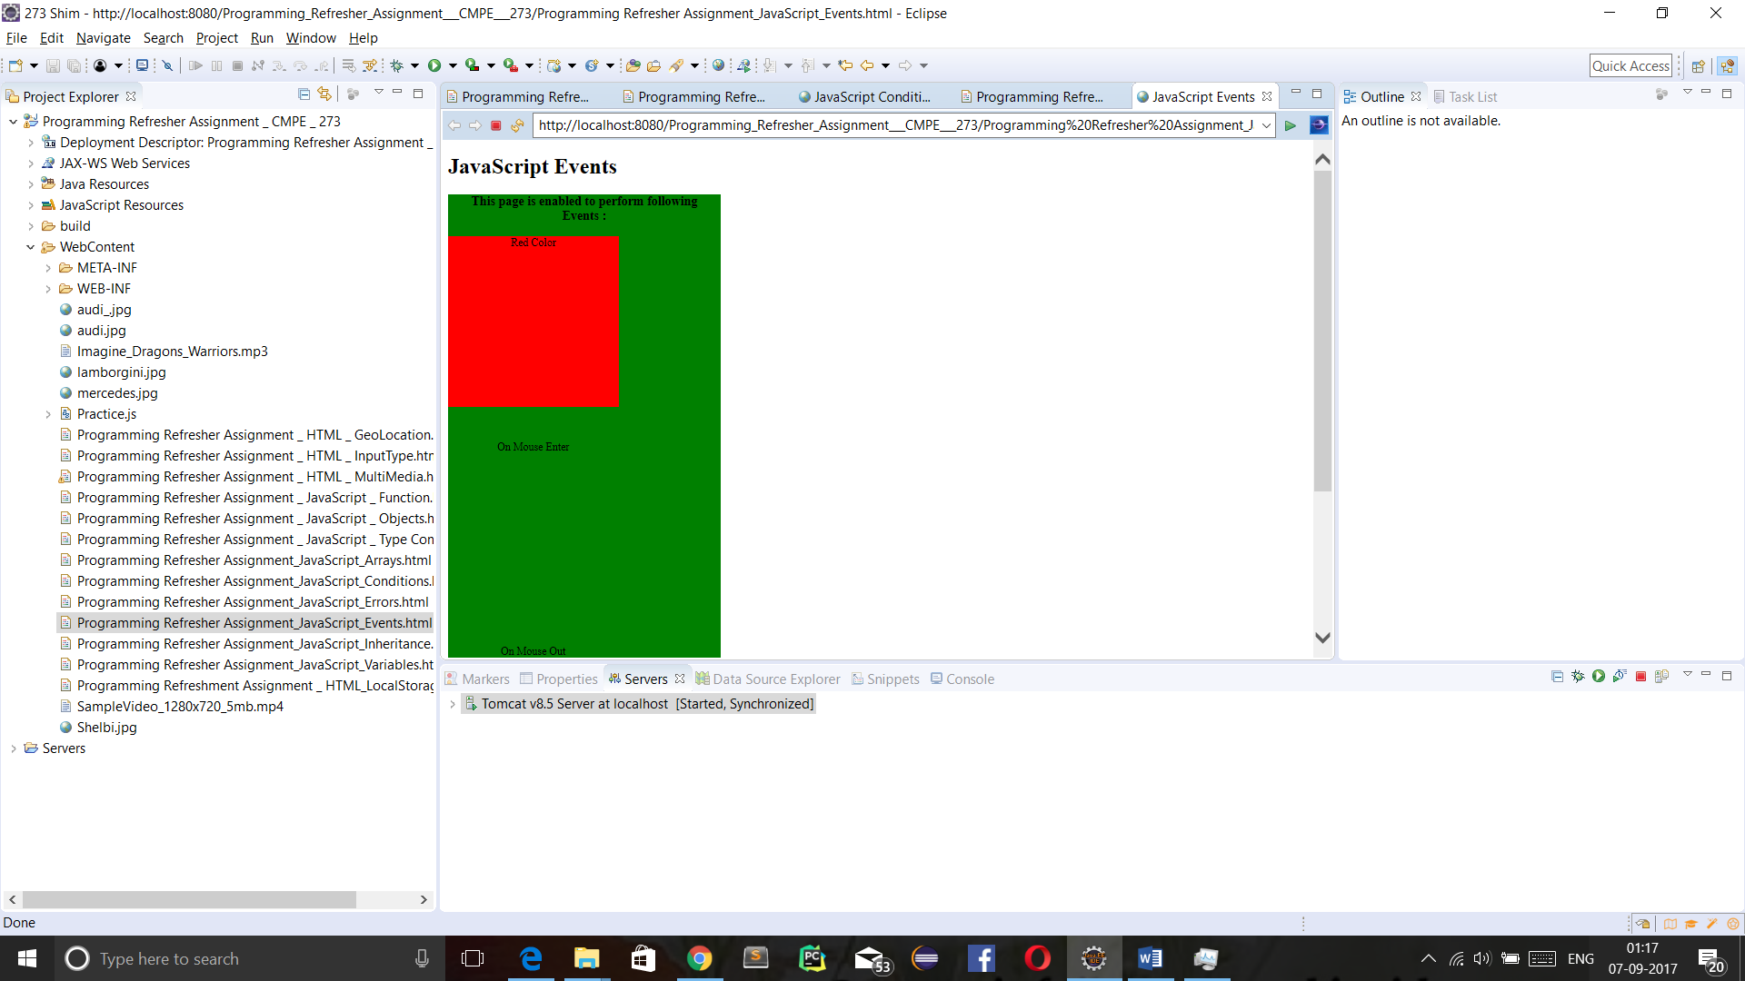

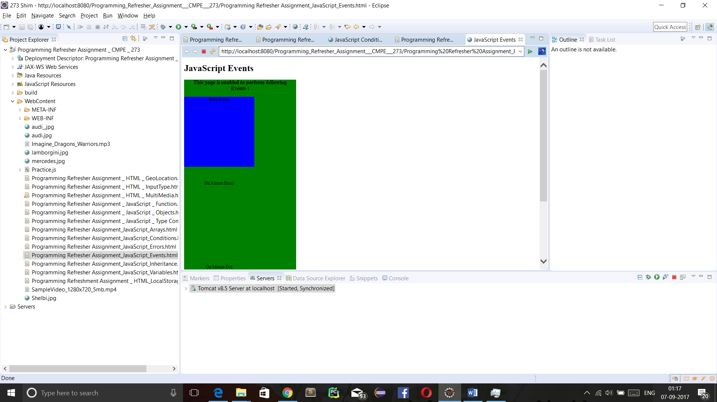

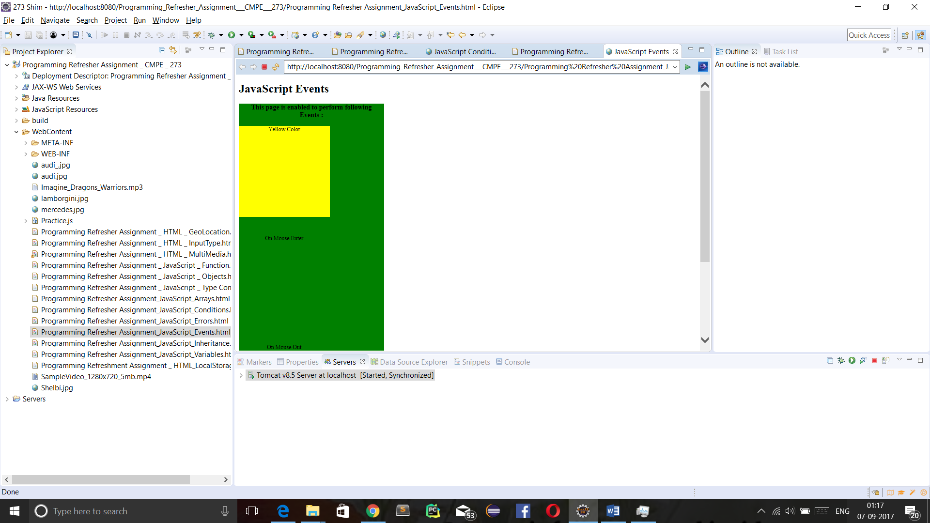

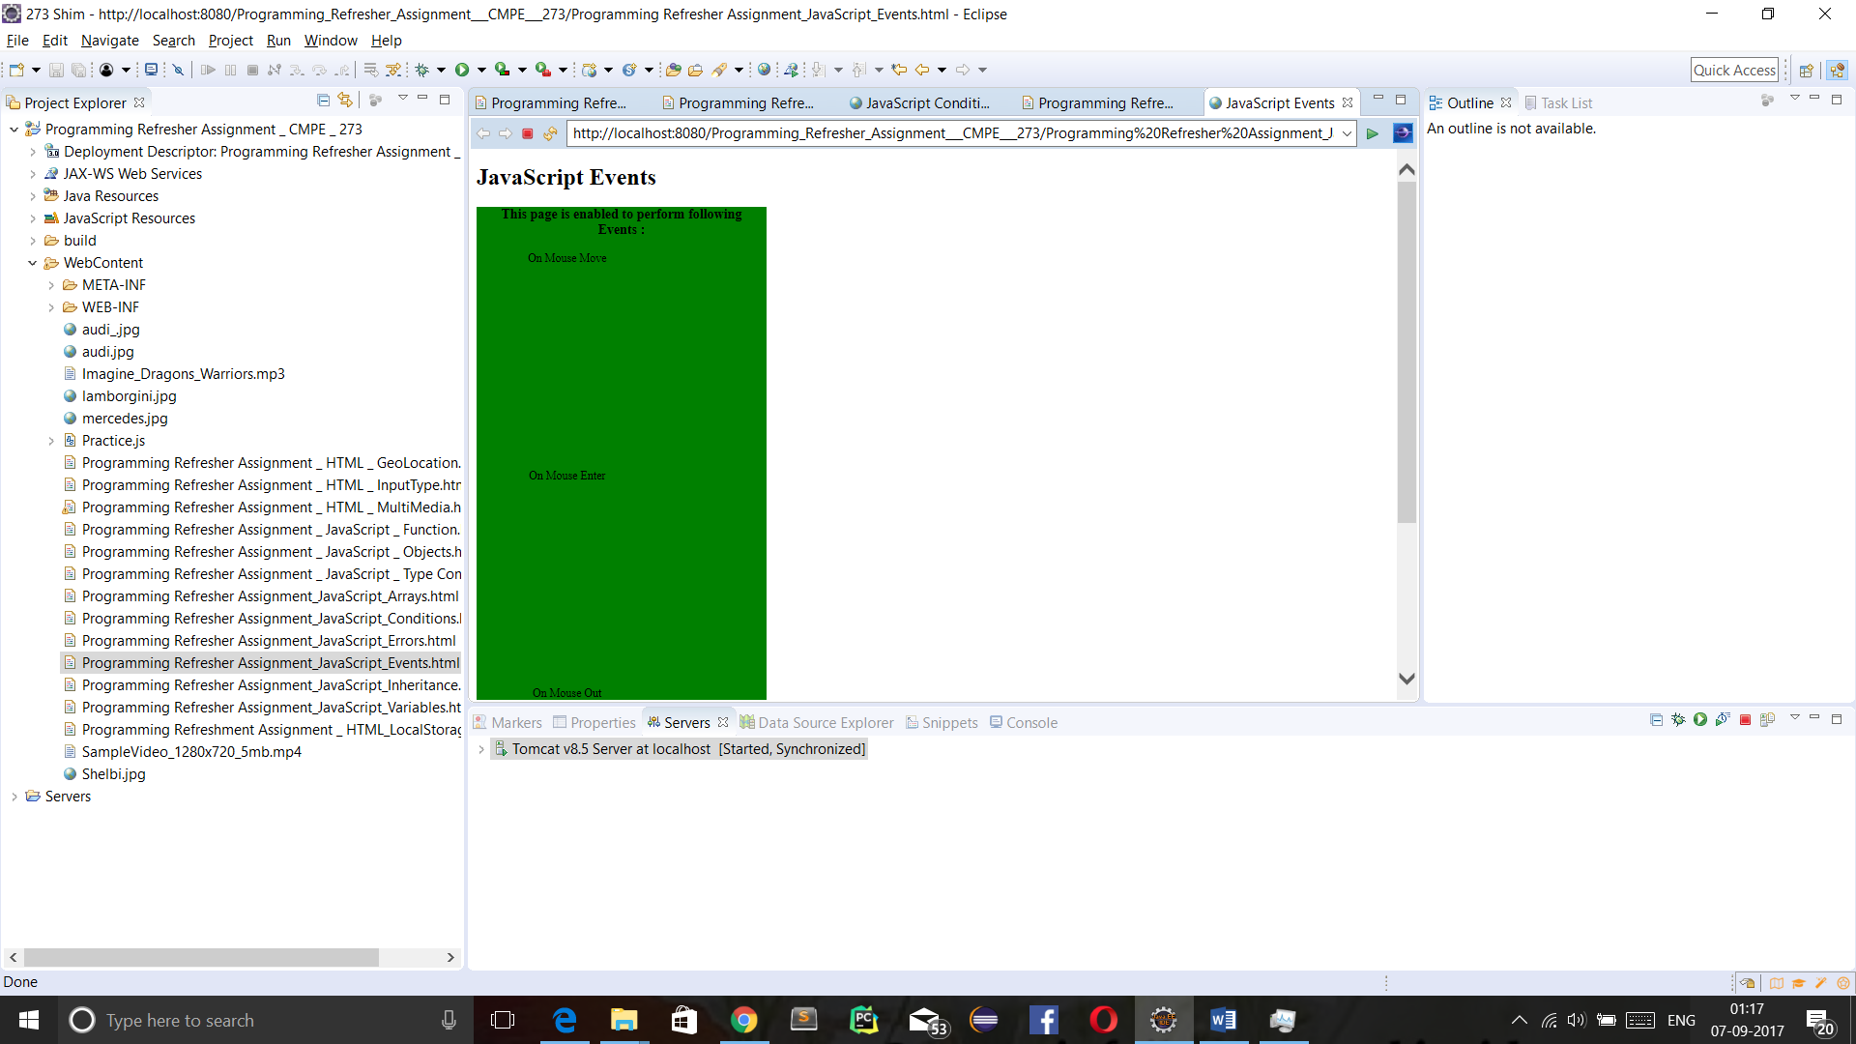

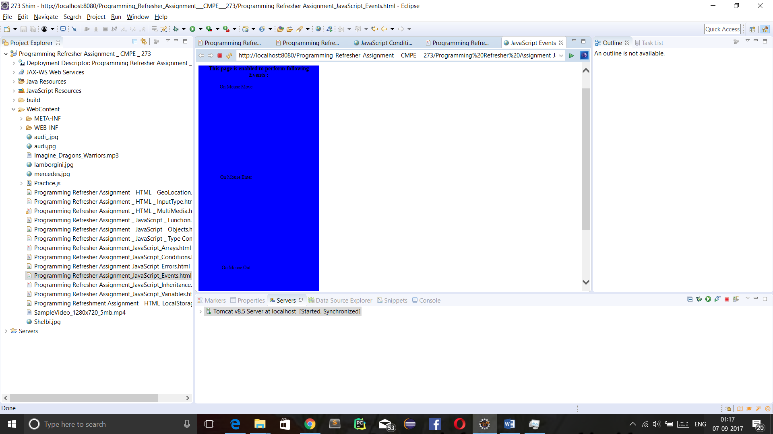

1. **Arrays :**

* **Introduction of Type Arrays :**

Array is a linear data structure. Array is used to store same type of elements, though a generic List array can store various types of elements in same array. All array elements are defined as adjacent elements in Memory. Thus, to maintain a huge array(having millions of elements) its required to have free memory or appropriate garbage collection methodology. Arrays are used to implement other kind of data structures: queues, stacks, trees and graphs, for matrix implementation etc.

* **Programming Question :**

Sort an array according to name and according to age using Javascript array.

* **Code:**

<!DOCTYPE html>

<html>

<head>

<meta charset=*"ISO-8859-1"*>

<meta name=*"Author"* content=*"Vishweshkumar Patel"*>

<meta name=*"Description"* content=*"Homework_1_CMPE_273 : JavaScript Arrays"*>

<meta name=*"keyword"* content=*" HTML, CSS, JavaScript, Arrays"*>

<meta name=*"last modified"* content=*"Sept 9,2017"*>

<meta name=*"viewport"* content=*"width=device-width; initial-scale=1.0"*>

<meta http-equiv=*"refresh"* content=*"120"*>

<title> JavaScript Arrays </title>

<style type=*"text/css"*>

**header,** **footer,** **section,** **article**{

display: *block*;

}

**section**{

text-align: *center*;

}

</style>

<script type=*"text/javascript"*>

**var** a = [];

**var** n = **false** ,age = **false**;

a.push({name:"Vishwesh",age:21});

a.push({name:"Keval",age:23});

a.push({name:"Abhijit",age:22});

a.push({name:"Sannisth",age:24});

a.push({name:"Harsh",age:22});

a.push({name:"Monang",age:25});

a.push({name:"Ashish",age:24});

a.push({name:"Raj",age:21});

a.push({name:"Jay",age:26});

a.push({name:"Milind",age:27});

**function** chooseFunction(){

**var** target = event.target || event.srcElement;

**var** id = target.id;

**var** c = id.toString();

**if** (c=="sortByName"){

n = **true**;

}

**else**{

age = **true**;

}

display();

}

**function** compare(a,b) {

**var** x,y ;

**if**(n){

x = a.name;

y = b.name;

}

**if**(age){

x = a.age;

y = b.age;

}

**if** (x < y)

**return** -1;

**else** **if** (x > y)

**return** 1;

**return** 0;

}

**function** display(){

a.sort(compare);

**var** html = "<table border='1|1'>";

html+="<tr>";

html+="<th> Name </th>";

html+="<th> Age </th>";

html+="</tr>";

**for** (**var** i = 0; i < a.length; i++) {

html+="<tr>";

html+="<td>"+a[i].name+"</td>";

html+="<td>"+a[i].age+"</td>";

html+="</tr>";

}

html+="</table>";

document.getElementById("display1").innerHTML = html;

n=**false**;

age=**false**;

}

</script>

</head>

<body style="align-content: *center*;">

<header>

<h1>JavaScript Arrays</h1>

</header>

<section>

<article>

<h3> Sort People By their first name and their age : </h3>

<button id=*"sortByName"* onclick="chooseFunction()">Sort By Name</button>

<button id=*"sortByAge"* onclick="chooseFunction()">Sort By Age</button>

<p id=*"display1"*></p>

</article>

</section>

<footer>

<h3> Created By : Vishweshkumar Patel </h3>

<h3> Contact @ vishweshkumar.patel@sjsu.edu </h3>

</footer>

</body>

</html>

* **Output’s Screenshot:**

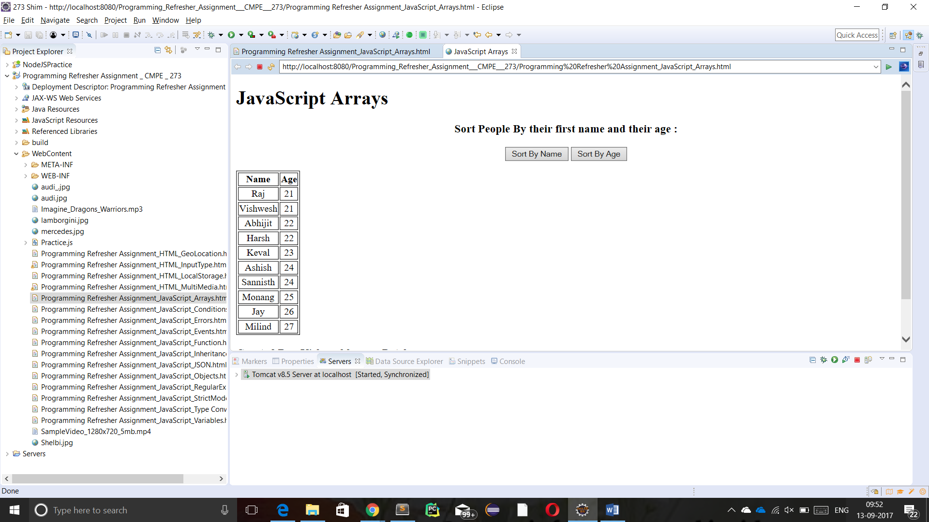

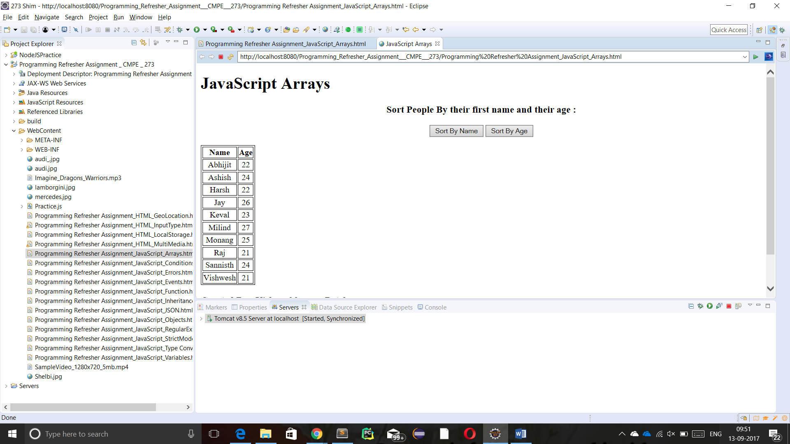

1. **Inheritances :**

* **Introduction of Inheritances :**

Inheritance provides a way to reuse the code through inheriting common properties and behaviour from parent.

* **Programming Question :**

Write a Javascript program that implements concept of inheritance through Generalized Person and Specialized Doctor and Engineer.

* **Code:**

<!DOCTYPE html>

<html>

<head>

<meta charset=*"ISO-8859-1"*>

<meta name=*"Author"* content=*"Vishweshkumar Patel"*>

<meta name=*"Description"* content=*"Homework_1_CMPE_273 : JavaScript Inheritance"*>

<meta name=*"keyword"* content=*" HTML, CSS, JavaScript, Inheritance"*>

<meta name=*"last modified"* content=*"Sept 8,2017"*>

<meta name=*"viewport"* content=*"width=device-width; initial-scale=1.0"*>

<meta http-equiv=*"refresh"* content=*"120"*>

<title> JavaScript Inheritance </title>

<style type=*"text/css"*>

**header,** **footer,** **section,** **article**{

display: *block*;

}

**section**{

text-align: *center*;

}

</style>

<script type=*"text/javascript"*>

**function** chooseFunction(){

**var** target = event.srcElement || event.target;

**var** id = target.id;

**var** person_type = id.toString();

**var** first = document.getElementById("first").value ;

**var** last = document.getElementById("last").value ;

**var** age = document.getElementById("age").value ;

**var** gender = document.getElementById("gender").value ;

**var** company = document.getElementById("company").value ;

**var** clinic = document.getElementById("clinic").value ;

**var** er;

**var** doc;

**var** html;

**if**(person_type == "Engineer"){

Engineer.prototype = Object.create(Person.prototype);

Engineer.prototype.constructor = Engineer;

er = **new** Engineer(first,last, age, gender, company);

er.greeting();

}

**else**{

Doctor.prototype = Object.create(Person.prototype);

Doctor.prototype.constructor = Doctor;

**var** doc = **new** Doctor(first,last, age, gender, clinic);

doc.greeting();

}

}

**function** Person(first, last, age, gender) {

**this**.name = {

first,

last

};

**this**.age = age;

**this**.gender = gender;

};

Person.prototype.greeting = **function**() {

alert('Hi! I\'m ' + **this**.name.first + '.');

};

**function** Engineer(first, last, age, gender, company) {

Person.call(**this**, first, last, age, gender);

**this**.company = company;

}

Engineer.prototype.degree = **function**(){

alert('!!'+ **this**.first +' have Master\'s degree !!');

}

Engineer.prototype.greeting = **function**() {

**var** prefix;

**if** (**this**.gender === 'male' || **this**.gender === 'Male' || **this**.gender === 'm' || **this**.gender === 'M') {

prefix = 'Mr.';

} **else** **if** (**this**.gender === 'female' || **this**.gender === 'Female' || **this**.gender === 'f' || **this**.gender === 'F') {

prefix = 'Mrs.';

} **else** {

prefix = 'Mx.';

}

alert('Hello. My name is ' + prefix + ' ' + **this**.name.last + ', and I work at ' + **this**.company + '.');

};

**function** Doctor(first, last, age, gender, clinic) {

Person.call(**this**, first, last, age, gender);

**this**.clinic = clinic;

}

Doctor.prototype.degree = **function**(){

alert('!!'+ **this**.first +' have M.B.B.S degree !!');

}

Doctor.prototype.greeting = **function**() {

**var** prefix;

**if** (**this**.gender === 'male' || **this**.gender === 'Male' || **this**.gender === 'm' || **this**.gender === 'M') {

prefix = 'Mr.';

} **else** **if** (**this**.gender === 'female' || **this**.gender === 'Female' || **this**.gender === 'f' || **this**.gender === 'F') {

prefix = 'Mrs.';

} **else** {

prefix = 'Mx.';

}

alert('Hello. My name is ' + prefix + ' ' + **this**.name.last + ', and I work at ' + **this**.clinic + '.');

}

</script>

</head>

<body>

<header>

<h1>JavaScript Inheritance</h1>

</header>

<section>

<article>

First Name: <input type=*"text"* id=*"first"*/> <br/> <br/>

Last Name: <input type=*"text"* id=*"last"*/> <br/> <br/>

Age: <input type=*"text"* id=*"age"* pattern=*"[0-9]{2}"*/> <br/> <br/>

Gender: <input type=*"radio"* id=*"gender"* name=*"gender"* value=*"male"*/>Male &nbsp; &nbsp;

<input type=*"radio"* id=*"gender"* name=*"gender"* value=*"female"*/>Female <br/> <br/>

Company: <input type=*"text"* id=*"company"*/> <br/> <br/>

Clinic: <input type=*"text"* id=*"clinic"*/> <br/> <br/>

Type of Person: <input type=*"radio"* name=*"p"* id=*"Engineer"* value=*"Engineer"* onchange=*"chooseFunction();"*/>Engineer &nbsp; &nbsp;

<input type=*"radio"* name=*"p"* id=*"Doctor"* value=*"Doctor"* onchange=*"chooseFunction();"*/>Doctor <br/> <br/>

</article>

</section>

<footer>

<h3> Created By : Vishweshkumar Patel </h3>

<h3> Contact @ vishweshkumar.patel@sjsu.edu </h3>

</footer>

</body>

</html>

* **Output’s Screenshot:**

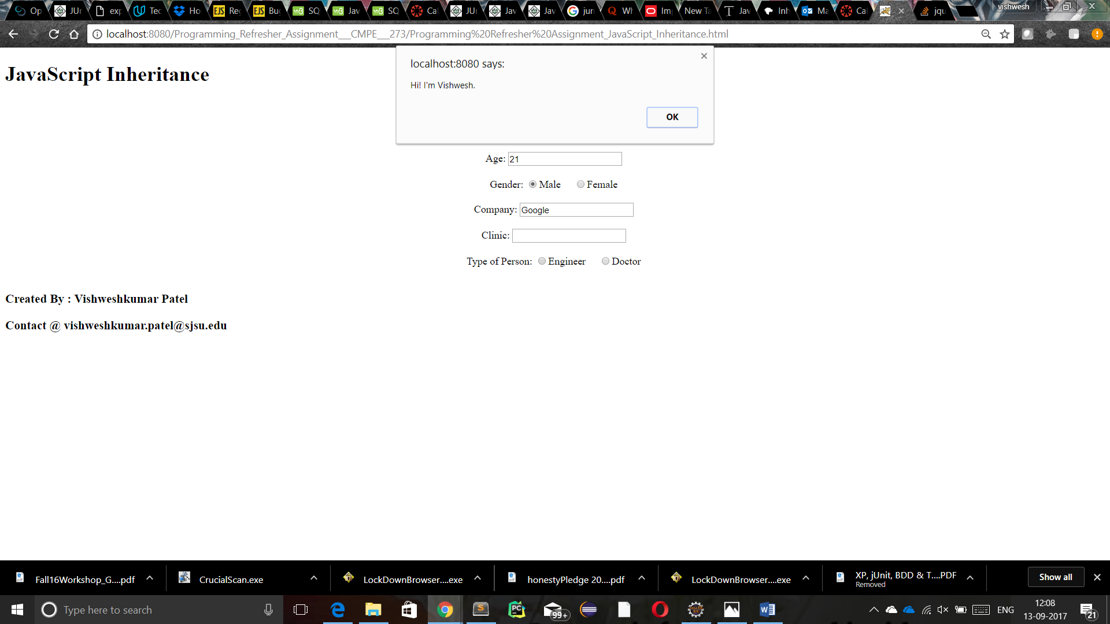

1. **Conditions** :

* **Introduction of Conditions:**

Conditions allows us to take different decisions based on different values of different variables. if, else if and else is one way to define conditions. while, do while and for is second way to implement conditions, they allow to loop over a variable up till condition is satisfied.

* **Programming Question :**

Take three variables as input namely monthly salary, age and monthly average balance and check your eligibility for credit card.

* **Code :**

<!DOCTYPE html>

<html>

<head>

<meta charset=*"ISO-8859-1"*>

<meta name=*"Author"* content=*"Vishweshkumar Patel"*>

<meta name=*"Description"* content=*"Homework_1_CMPE_273 : JavaScript Conditions"*>

<meta name=*"keyword"* content=*" HTML, CSS, JavaScript, Conditions"*>

<meta name=*"last modified"* content=*"Sept 6,2017"*>

<meta name=*"viewport"* content=*"width=device-width, initial-scale=1.0"*>

<meta http-equiv=*"refresh"* content=*"120"*>

<title> JavaScript Conditions </title>

<style type=*"text/css"*>

**header,** **footer,** **section,** **article**{

display: *block*;

}

**section**{

text-align: *center*;

}

</style>

<script type=*"text/javascript"*>

**function** checkEligiblity(){

**var** salary = Number(document.getElementById("salary").value);

**var** age = Number(document.getElementById("age").value);

**var** monthlyAvgBalance = Number(document.getElementById("monthly avg balance").value);

**if**(salary>4000 && monthlyAvgBalance>2500){

**var** credit = Math.max(salary,monthlyAvgBalance);

document.getElementById("result").innerHTML = "!! Congratulation !! Your Credit Card is approved with "+credit+"$ credit per Month!!";

}

**else** **if**(salary>4000){

document.getElementById("result").innerHTML = "!! Congratulation !! Your Credit Card is approved with "+salary+"$ credit per Month!!";

}

**else** **if**(monthlyAvgBalance>2500){

document.getElementById("result").innerHTML = "!! Congratulation !! Your Credit Card is approved with "+monthlyAvgBalance+"$ credit per Month!!";

}

**else** **if** (salary>2500 && age<40){

document.getElementById("result").innerHTML = "!! Congratulation !! Your Credit Card is approved with 2000$ credit per Month!!";

}

**else** **if**(age>50 && monthlyAvgBalance>2000){

document.getElementById("result").innerHTML = "!! Congratulation !! Your Credit Card is approved with 1800$ credit per Month!!";

}

**else** **if**(salary>3000 && age>40 && age<50 && monthlyAvgBalance>1200){

document.getElementById("result").innerHTML = "!! Congratulation !! Your Credit Card is approved with 4000$ credit per Month!!";

}

**else**{

document.getElementById("result").innerHTML = " Sorry, You are not eligible ";

}

}

</script>

</head>

<body>

<header>

<h1>JavaScript Conditions</h1>

</header>

<section>

<article>

<h3> !! Check if you are eligible for Credit Card !! </h3>

</article>

<article>

Salary Per Month: <input id=*"salary"* type=*"text"* /> <br/> <br/>

Age : <input id=*"age"* type=*"text"* /> <br/> <br/>

Monthly Avg Balance : <input id=*"monthly avg balance"* type=*"text"* /> <br/> <br/>

<input type=*"button"* onClick="checkEligiblity()" value=*"!!Check Eligibility!!"*/> <br/> <br/>

<p id=*"result"*></p>

</article>

</section>

<footer>

<h3> Created By : Vishweshkumar Patel </h3>

<h3> Contact @ vishweshkumar.patel@sjsu.edu </h3>

</footer>

</body>

</html>

* **Output’s Screenshot :**

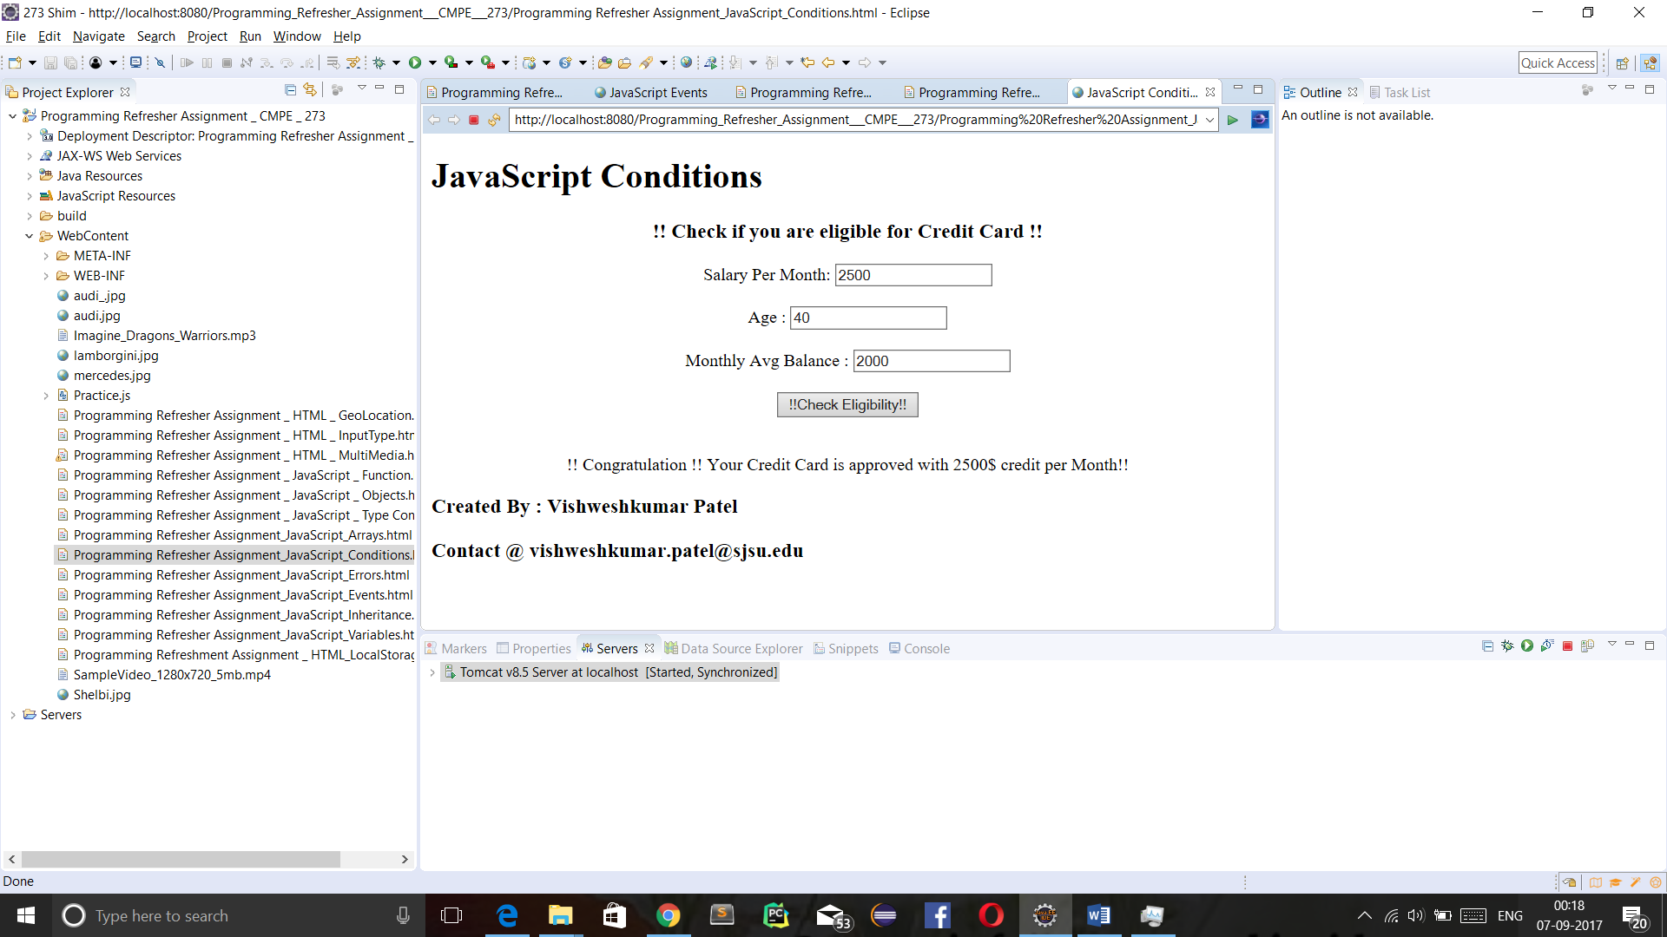

1. **Regular Expression:**

* **Introduction of Regular Expressios :**

Regular Expressions are used to validate different inputs. Regular expression can be used to perform text search and text replace operation. RegEx can be a single character pattern or complex string pattern.

* **Programming Question :**

Write a program that takes input string and replaces “Patel” word with “Shah” using regular expression.

* **Code:**

<!DOCTYPE html>

<html>

<head>

<meta charset=*"ISO-8859-1"*>

<meta name=*"Author"* content=*"Vishweshkumar Patel"*>

<meta name=*"Description"* content=*"Homework_1_CMPE_273 : JavaScript Regular Expression"*>

<meta name=*"keyword"* content=*" HTML, CSS, JavaScript, Regular Expression"*>

<meta name=*"last modified"* content=*"Sept 10,2017"*>

<meta name=*"viewport"* content=*"width=device-width, initial-scale=1.0"*>

<meta http-equiv=*"refresh"* content=*"120"*>

<title> JavaScript Regular Expression</title>

<style type=*"text/css"*>

**header,** **footer,** **section,** **article**{

display: *block*;

}

**section**{

text-align: *center*;

}

</style>

<script type=*"text/javascript"*>

**function** regEx(){

**var** input = document.getElementById("inputString").value;

**var** res = input.replace(/Patel/i, "Shah");

document.getElementById("inputString").value = res;

}

</script>

</head>

<body>

<header>

<h1>JavaScript Regular Expression</h1>

</header>

<section>

<article>

<h3> Replace Patel word by Shah in following input String : </h3> <br/> <br/>

Input: <input type=*"text"* id=*"inputString"*/> <br/> <br/>

<button onclick="regEx();"> Check & Replace </button>

</article>

</section>

<footer>

<h3> Created By : Vishweshkumar Patel </h3>

<h3> Contact @ vishweshkumar.patel@sjsu.edu </h3>

</footer>

</body>

</html>

* **Output’s Screenshot:**

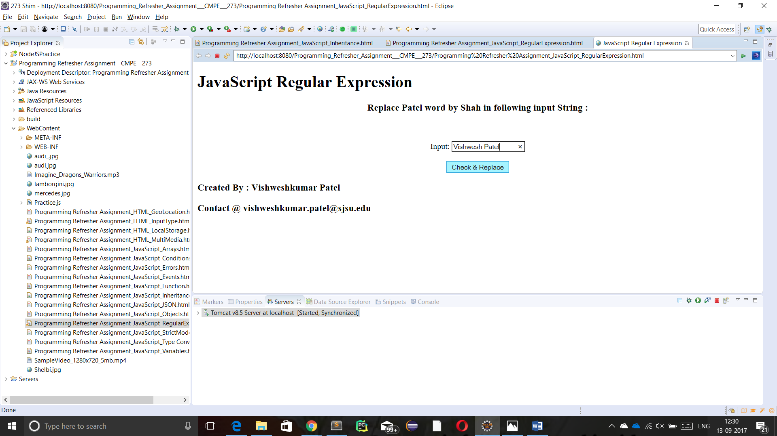

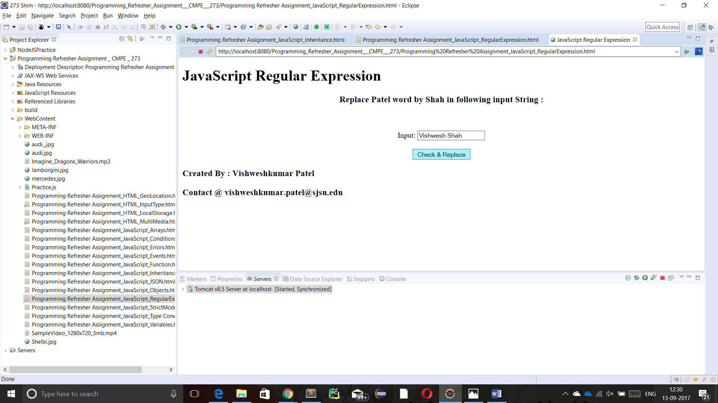

1. **Strict Mode :**

* **Introduction of Strict Mode :**

“use strict”; keyword is used to define strict mode in Javascript. Strict mode has some strict rules that are must be followed. For example, we can’t do variable hoisting functionality of JavaScript while in Scriptmode.

* **Programming Question :**

Write a program that displays various Strict mode related errors.

* **Code:**

<!DOCTYPE html>

<html>

<head>

<meta charset=*"ISO-8859-1"*>

<meta name=*"Author"* content=*"Vishweshkumar Patel"*>

<meta name=*"Description"* content=*"Homework_1_CMPE_273 : JavaScript Strict Mode"*>

<meta name=*"keyword"* content=*" HTML, CSS, JavaScript, Strict Mode"*>

<meta name=*"last modified"* content=*"Sept 9,2017"*>

<meta name=*"viewport"* content=*"width=device-width, initial-scale=1.0"*>

<meta http-equiv=*"refresh"* content=*"120"*>

<title> JavaScript Strict Mode</title>

<style type=*"text/css"*>

**header,** **footer,** **section,** **article**{

display: *block*;

}

**section**{

text-align: *center*;

}

</style>

<script type=*"text/javascript"*>

"use strict";

**function** getStrictError(){

**var** s1 = "x=9.81;";

**var** s2 = "var x = 3.14; delete x;";

**var** s3 = "function x(par1, par2) {}; delete x;";

**var** s4 = "function x(par1, par1) {}; ";

**var** s5 = "var x = 010;";

**var** s6 = "var x = \\010;";

**var** s7 = "var obj = {}; Object.defineProperty(obj,\"x\", {value:0, writable:false}); obj.x = 3.14; ";

**var** s8 = "var obj = {get x() {return 0} }; obj.x = 3.14; ";

**var** s9 = "with (Math){x = cos(2)};";

**var** s10 = "var protected = 7;";

//var target = event.target || event.srcElement ;

//var id = target.id;

//var c = id.toString();

**var** c = document.getElementById("options").value;

**var** command;

**switch**(c){

**case** "lateDeclaration":

command = s1;

**break**;

**case** "reservedKeyword":

command = s10;

**break**;

**case** "withStatement":

command = s9;

**break**;

**case** "getOnlyProperty":

command = s8;

**break**;

**case** "getOnlyProperty":

command = s7;

**break**;

**case** "usingEscapeCharacter":

command = s6;

**break**;

**case** "usingOctal":

command = s5;

**break**;

**case** "duplicatingParameter":

command = s4;

**break**;

**case** "deletionFunction":

command = s3;

**break**;

**case** "deletionVariable":

command = s2;

**break**;

**default**:

}

**try**{

eval(command);

}

**catch**(err){

document.getElementById("display").innerHTML = " Error Name :" +err.name +" <br/> Error Message :" + err.message;;

}

}

</script>

</head>

<body>

<header>

<h1>JavaScript Strict Mode</h1>

</header>

<section>

<article>

<h3> Choose a command to know related Strict Mode Error : </h3>

<select name=*"option"* id=*"options"* onchange=*"getStrictError()"* >

<option value=*"lateDeclaration"* > lateDeclaration </option>

<option value=*"deletionVariable"* > deletionVariable </option>

<option value=*"deletionFunction"* > deletionFunction </option>

<option value=*"duplicatingParameter"* > duplicatingParameter </option>

<option value=*"usingOctal"* > usingOctal </option>

<option value=*"usingEscapeCharacter"* > usingEscapeCharacter </option>

<option value=*"writingToReadOnlyProperty"* > writingToReadOnlyProperty </option>

<option value=*"getOnlyProperty"* > getOnlyProperty </option>

<option value=*"withStatement"* > withStatement </option>

<option value=*"reservedKeyword"* > reservedKeyword </option>

</select>

<p id=*"display"*></p>

</article>

</section>

<footer>

<h3> Created By : Vishweshkumar Patel </h3>

<h3> Contact @ vishweshkumar.patel@sjsu.edu </h3>

</footer>

</body>

</html>

* **Output’s Screenshot:**

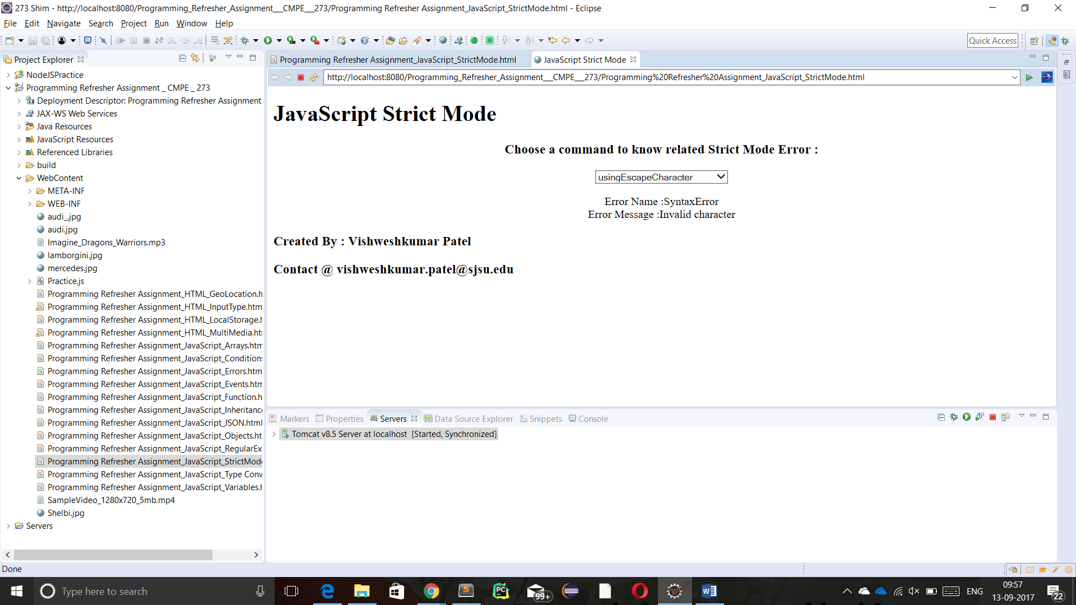

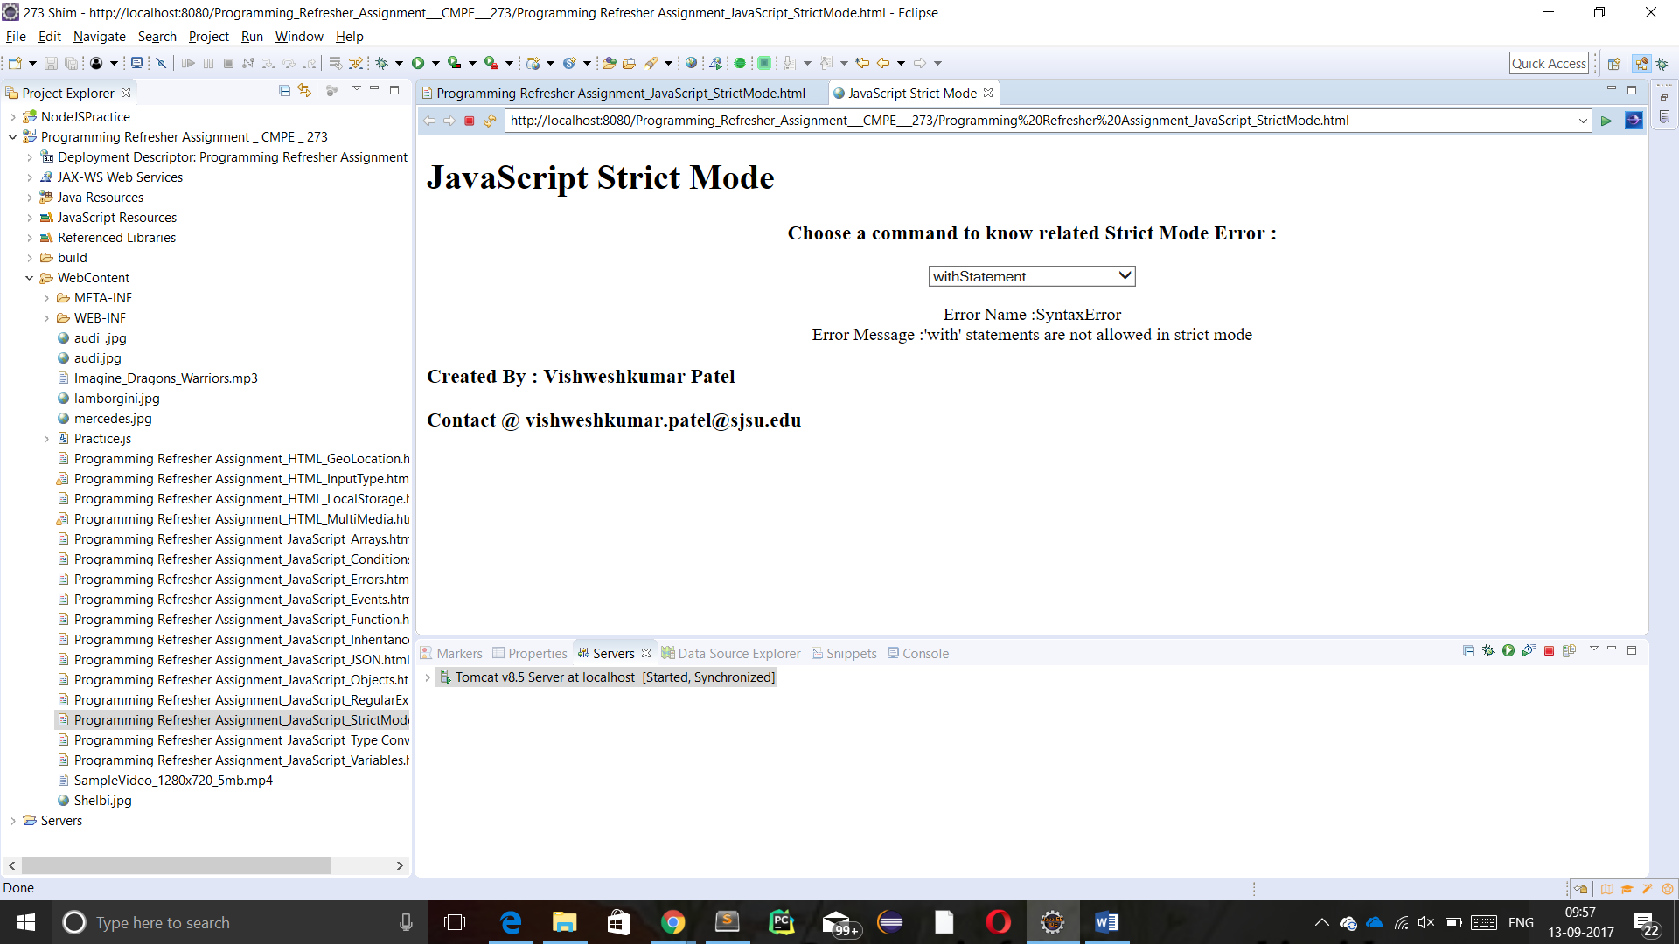

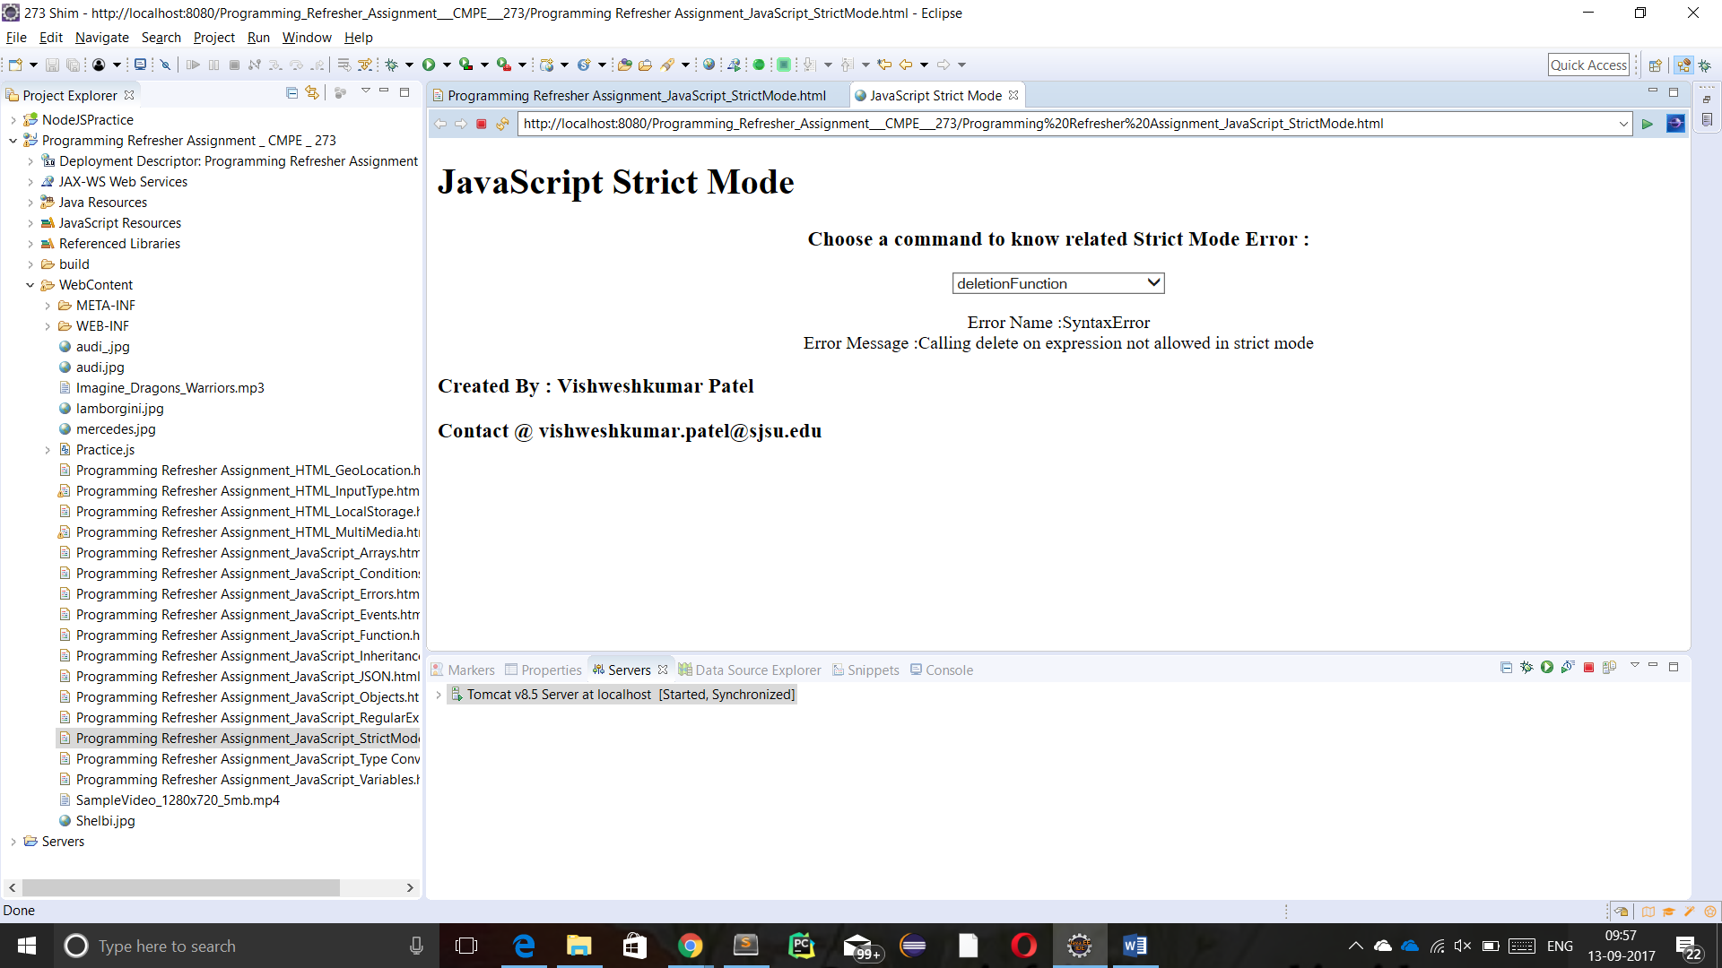

1. **Errors :**

* **Introduction of Errors :**

Javascript handels errors using try, catch, finally and throw functionality. There exist various kinds of errors may present in code : EvalError, RangeError, Reference Error, SyntaxError, TypeError, URIError. Try statement allows to write code that may contain error, catch catches errors thrown by try block, finally executes the code that must be executed everytime, regardless error’s presence.

* **Programming Question :**

Design a program that takes input as Javascript script and display error if any present using Error handling try ---- catch functionality.

* **Code:**

<!DOCTYPE html>

<html>

<head>

<meta charset=*"ISO-8859-1"*>

<meta name=*"Author"* content=*"Vishweshkumar Patel"*>

<meta name=*"Description"* content=*"Homework_1_CMPE_273 : JavaScript Errors"*>

<meta name=*"keyword"* content=*" HTML, CSS, JavaScript, Errors"*>

<meta name=*"last modified"* content=*"Sept 7,2017"*>

<meta name=*"viewport"* content=*"width=device-width; initial-scale=1.0"*>

<meta http-equiv=*"refresh"* content=*"120"*>

<title> JavaScript Errors </title>

<style type=*"text/css"*>

**header,** **footer,** **section,** **article**{

display: *block*;

}

**section**{

text-align: *center*;

}

</style>

<script type=*"text/javascript"*>

**function** checkError(){

**var** x = document.getElementById("errCommand").value;

**try**{

eval(x);

}

**catch**(err){

document.getElementById("displayError").innerHTML = " Error Name :" +err.name +" <br/> Error Message :" + err.message;

}

}

</script>

</head>

<body>

<header>

<h1>JavaScript Errors</h1>

</header>

<section>

<article>

<h3> Check any error present in JavaScript Code : </h3>

<input type=*"text"* id=*"errCommand"*/>

<input type=*"button"* onclick="checkError();" value=*"Check Error"* />

<p id=*"displayError"*></p>

</article>

</section>

<footer>

<h3> Created By : Vishweshkumar Patel </h3>

<h3> Contact @ vishweshkumar.patel@sjsu.edu </h3>

</footer>

</body>

</html>

* **Output’s Screenshot:**

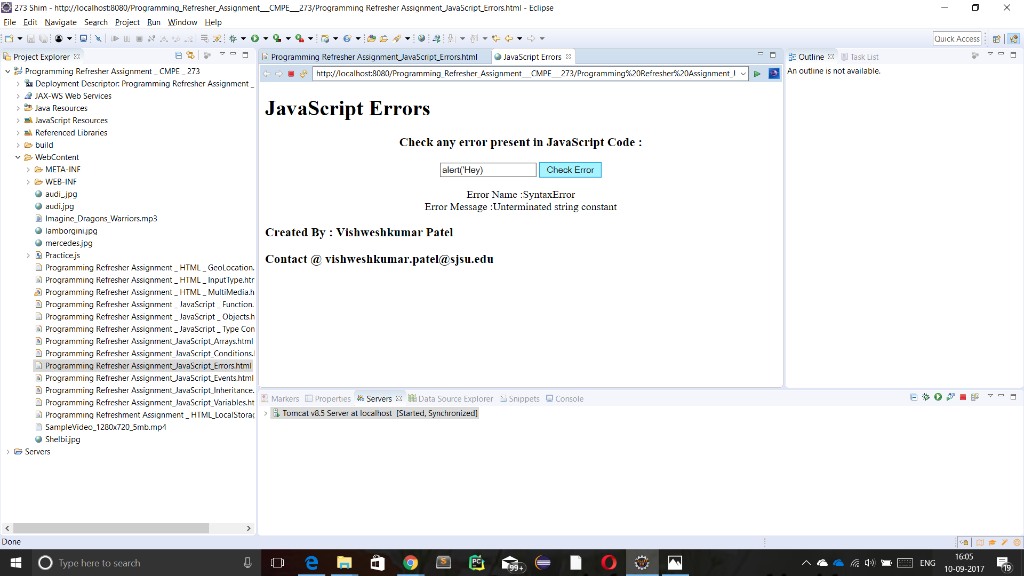

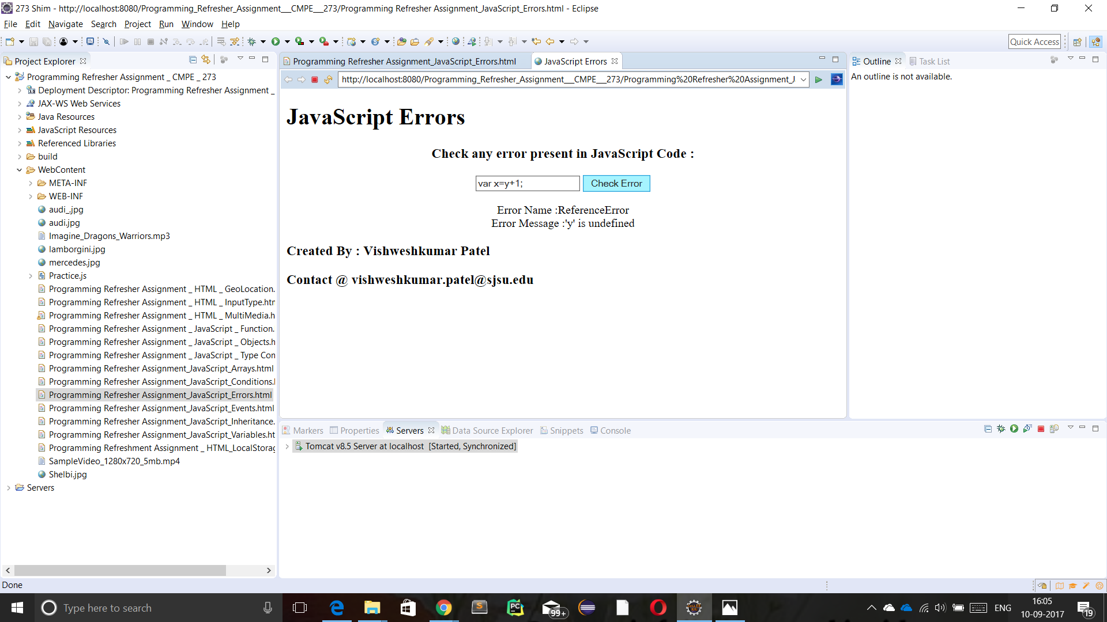

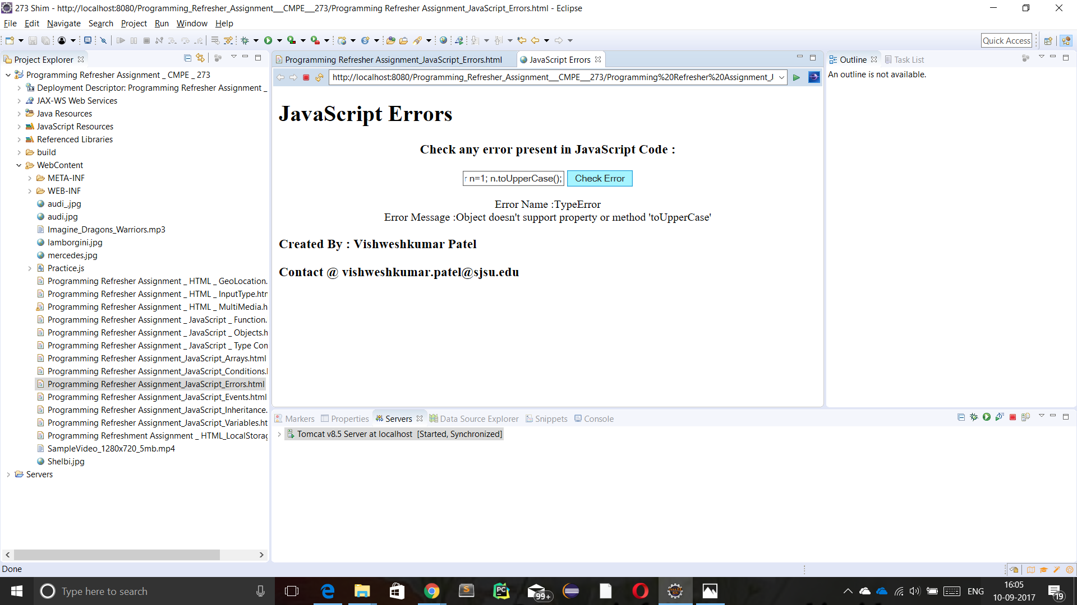

1. **Type Conversion** :

* **Introduction of Type Conversion :**

Javascript supports 5 different data types : string, number , Boolean , object and function and 3 types of objects : Object , Date and Array, and 2 types that doesn’t contain values : null and undefined.

* **Programming Question :**

Convert given decimal number to Hexadecimal, Octal, Binary, String, Boolean type variable to decimal and float type variable to decimal and fixed precision of 3 points.

* **Code :**

<!DOCTYPE html>

<html>

<head>

<meta charset=*"ISO-8859-1"*>

<meta name=*"Author"* content=*"Vishweshkumar Patel"*>

<meta name=*"Description"* content=*"Homework_1_CMPE_273 : JavaScript Type Conversion"*>

<meta name=*"keyword"* content=*" HTML, CSS, JavaScript, Type Conversion "*>

<meta name=*"last modified"* content=*"Sept 3,2017"*>

<meta name=*"viewport"* content=*"width=device-width, initial-scale=1.0"*>

<meta http-equiv=*"refresh"* content=*"120"*>

<title> JavaScript Type Conversion </title>

<style type=*"text/css"*>

**header,** **footer,** **section,** **article**{

display: *block*;

}

</style>

<script type=*"text/javascript"*>

**function** chooseFunction(){

**var** target = event.target || event.srcElement;

**var** id = target.id;

**var** c = id.toString();

**switch**(c){

**case** "hex" :

convertToHex();

**break**;

**case** "decimal" :

convertToDecimal();

**break**;

**case** "octal" :

convertToOctal();

**break**;

**case** "binary" :

convertToBinary();

**break**;

**case** "string" :

convertToString();

**break**;

**case** "boolean":

convertToBoolean();

**break**;

**case** "float to decimal":

floatToDecimal();

**break**;

**case** "float to fixed Precision":

floatToFixedFloat();

**break**;

**case** "String to decimal":

stringToDecimal();

**break**;

**default**:

}

}

**function** convertToHex(){

**var** n = document.getElementById("number").value;

r = parseInt(n,10);

r = r.toString(16);

document.getElementById("result").innerHTML = " Decimal Number "+ n + " converted to Hexadecimal number = " + r + ". ";

}

**function** convertToOctal(){

**var** n = document.getElementById("number").value;

r = parseInt(n,10);

r = r.toString(8);

document.getElementById("result").innerHTML = " Decimal Number "+ n + " converted to Octal number = " + r + ". ";

}

**function** convertToBinary(){

**var** n = parseInt(document.getElementById("number").value,10);

r = parseInt(n,10);

r = r.toString(2);

document.getElementById("result").innerHTML = " Decimal Number "+ n + " converted to Binary number = " + r + ". ";

}

**function** convertToString(){

**var** n = document.getElementById("number").value;

document.getElementById("result").innerHTML = " Decimal Number "+ n + " converted to String number = " + n.toString() + ". " ;

}

**function** convertToBoolean(){

**var** n = document.getElementById("number").value;

**var** x = **true**;

**var** y = **false**;

**if**(n>0){

document.getElementById("result").innerHTML = " Decimal Number "+ n + " converted to Boolean number = " + x + ". ";

}

**else**{

document.getElementById("result").innerHTML = " Decimal Number "+ n + " converted to Boolean number = " + y + ". ";

}

}

**function** stringToDecimal(){

**var** n = document.getElementById("number").value;

n = Number(n);

document.getElementById("result").innerHTML = " String "+ document.getElementById("number").value + " converted to number = " + n + ". " ;

}

**function** floatToDecimal(){

**var** n = document.getElementById("number").value;

n = parseInt(n);

document.getElementById("result").innerHTML = " Float Number "+ document.getElementById("number").value + " converted to Decimal number = " + n + ". " ;

}

**function** floatToFixedFloat(){

**var** n = document.getElementById("number").value;

n = n.toFixed(3);

document.getElementById("result").innerHTML = " Float Number "+ document.getElementById("number").value + " converted to 3 precision number = " + n + ". " ;

}

</script>

</head>

<body>

<header>

<h1> JavaScript : Type Conversion </h1>

</header>

<section>

<article>

<h3> Enter a number : </h3>

<input type=*"text"* id=*"number"* required/> <br/> <br/>

</article>

<article>

<h3> Convert to : </h3>

<input type=*"radio"* name=*"option"* id=*"hex"* onchange=*"chooseFunction()"*/> Hexadecimal <br/>

<input type=*"radio"* name=*"option"* id=*"octal"* onchange=*"chooseFunction()"*/> Octal <br/>

<input type=*"radio"* name=*"option"* id=*"binary"* onchange=*"chooseFunction()"*/> Binary <br/>

<input type=*"radio"* name=*"option"* id=*"string"* onchange=*"chooseFunction()"*/> String <br/>

<input type=*"radio"* name=*"option"* id=*"boolean"* onchange=*"chooseFunction()"*/> Boolean <br/>

<input type=*"radio"* name=*"option"* id=*"float to decimal"* onchange=*"chooseFunction()"*/> Float to Decimal <br/>

<input type=*"radio"* name=*"option"* id=*"float to fixed Precision"* onchange=*"chooseFunction()"*/> Float to 3 precision <br/>

<input type=*"radio"* name=*"option"* id=*"String to decimal"* onchange=*"chooseFunction()"*/> String to Decimal <br/>

</article>

<article>

<br/>

<h3 id=*"result"*> </h3>

</article>

</section>

<footer>

<h2> Created By : Vishweshkumar Patel </h2>

<h2> Contact @ vishweshkumar.patel@sjsu.edu </h2>

</footer>

</body>

</html>

* **Output’s Screenshot :**

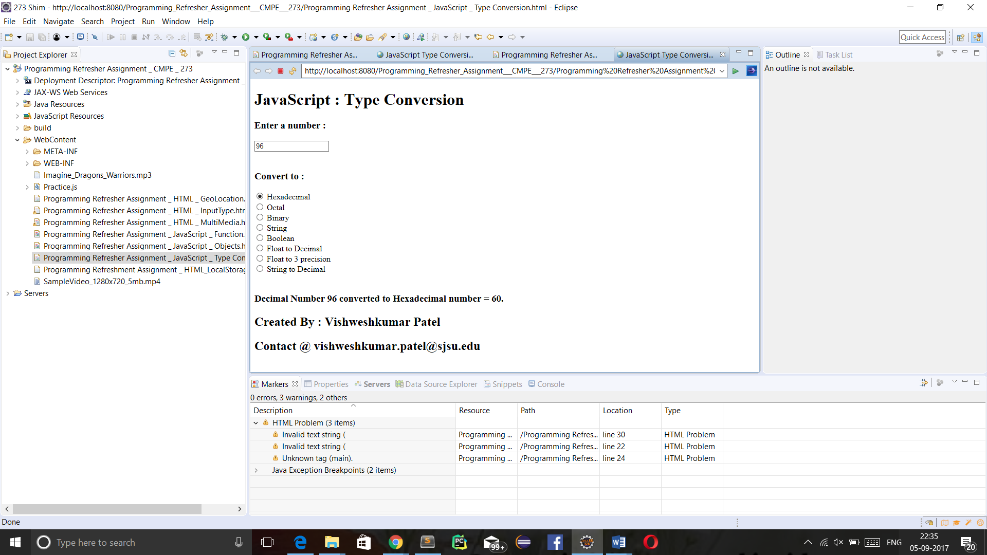

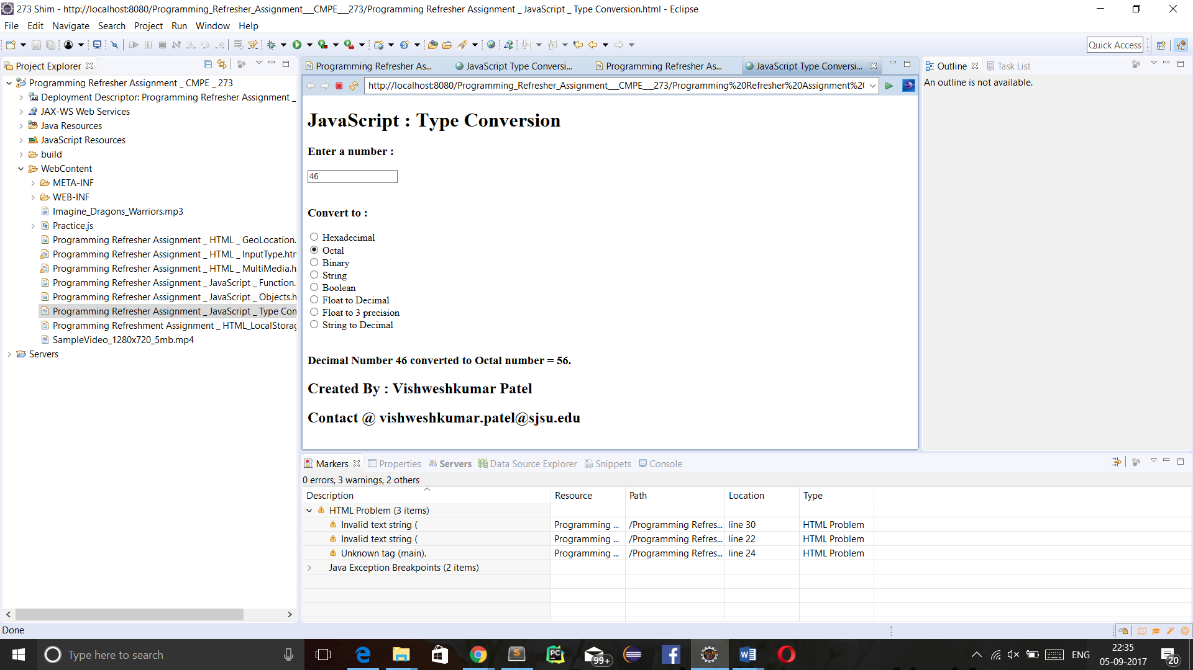

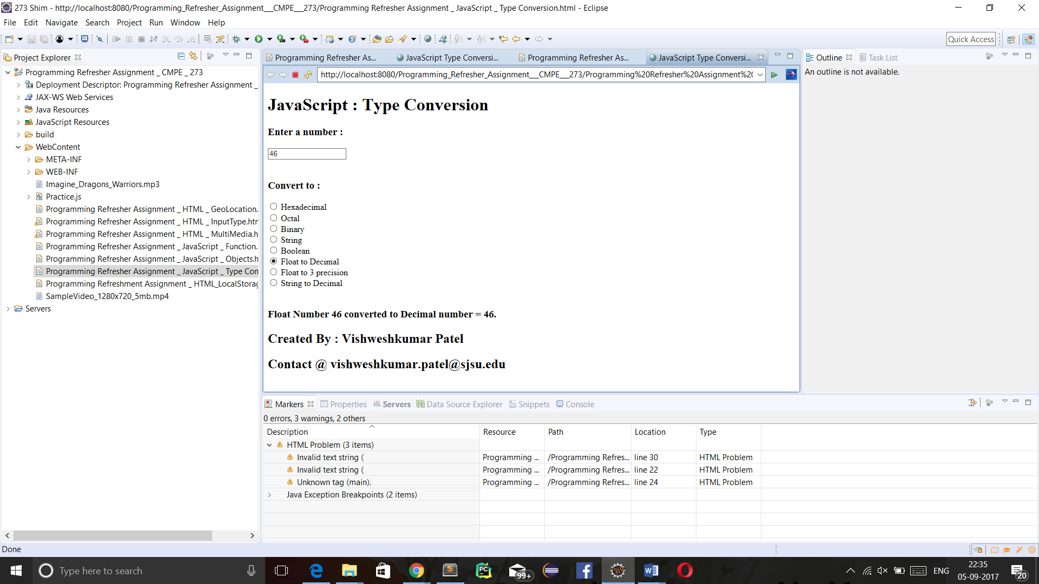

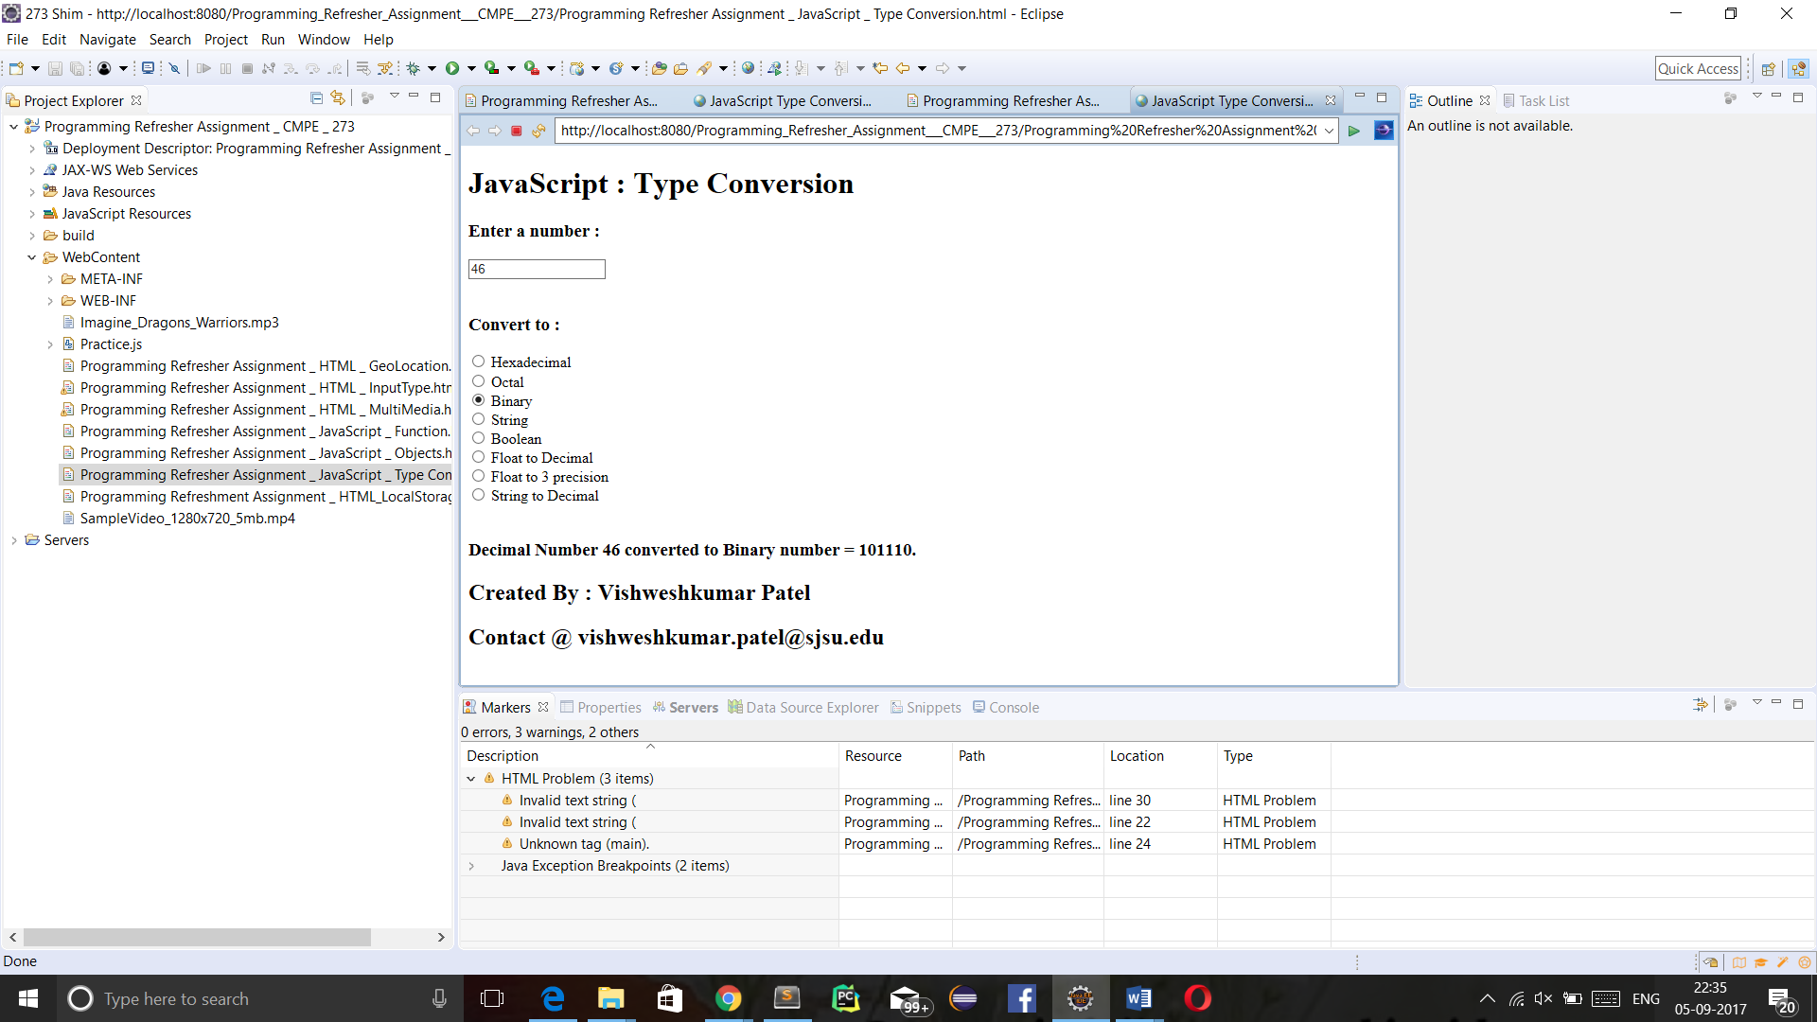

1. **JSON :**

* **Introduction of JSON :**

JSON stands for Javascript Object Notation, its used to store and exchange the data in javascript object. JSON is text only format, so we can parse JSON to Javascript object and vice versa.

* **Programming Question :**

Program a JSON object which contains car type , car name , horsepower , MSRP and its image and display them.

* **Code:**

<!DOCTYPE html>

<html>

<head>

<meta charset=*"ISO-8859-1"*>

<meta name=*"Author"* content=*"Vishweshkumar Patel"*>

<meta name=*"Description"* content=*"Homework_1_CMPE_273 : JavaScript JSON"*>

<meta name=*"keyword"* content=*" HTML, CSS, JavaScript, JSON"*>

<meta name=*"last modified"* content=*"Sept 10,2017"*>

<meta name=*"viewport"* content=*"width=device-width, initial-scale=1.0"*>

<meta http-equiv=*"refresh"* content=*"120"*>

<title> JavaScript JSON</title>

<style type=*"text/css"*>

**header,** **footer,** **section,** **article**{

display: *block*;

}

**section**{

text-align: *center*;

}

</style>

<script type=*"text/javascript"*>

**function** loadDetails(){

**var** cars_string = '{ "cars" : ['+

' {"name":"audi" , "type":"Audi", "model":"R8", "color":"Black" , "MSRP": "From $162,900" , "Horsepower": "540 to 610 hp" , "image_src": "audi_.jpg"} ,' +

' {"name":"shelbi" , "type":"Ford", "model":"GT350", "color":"Black" , "MSRP": "From $54,845" , "Horsepower": "526 hp", "image_src": "Shelbi.jpg" } ,'+

' {"name":"mercedes" , "type":"Mercedes", "model":"SLS AMG", "color":"Ash" , "Horsepower": "583 hp" , "MSRP": "From $200,00" , "image_src": "mercedes.jpg"} ,'+

' {"name":"lamborgini" , "type":"Lamborgini", "model":"Aventador", "color":"Black" ,"MSRP": "From $399,500" , "Horsepower": "691 to 740 hp", "image_src": "lamborgini.jpg"} '+

']} ' ;

**var** obj = JSON.parse(cars_string);

**var** target = event.target || event.srcElement;

**var** id = target.id;

**var** c = id.toString();

**switch**(c){

**case** "audi" :

**var** car = obj.cars[0];

**break**;

**case** "Shelbi" :

**var** car = obj.cars[1];

**break**;

**case** "mercedes" :

**var** car = obj.cars[2];

**break**;

**case** "lamborgini" :

**var** car = obj.cars[3];

**break**;

**default**:

}

document.getElementById("car_detail").innerHTML = '<br/> <img align="center" src='+ car.image_src +' alt="!! Image not available. !!" width="800px" height="500px" /> <br/> <br/> <br/> '

+ ' Car Type : <input type="text" name="type" value="' + car.type + '" disabled/> <br/> <br/> '

+ ' Car Model : <input type="text" name="model" value="' + car.model + '" disabled/> <br/> <br/> '

+ ' Car Color : <input type="text" name="color" value="' + car.color + '" disabled/> <br/> <br/> '

+ ' Car MSRP : <input type="text" name="MSRP" value="' + car.MSRP + '" disabled/> <br/> <br/> '

+ ' Car HorsePower : <input type="text" name="Horsepower" value="' + car.Horsepower + '" disabled/> <br/> <br/> ' ;

}

</script>

</head>

<body style="align-content: *center*;">

<header>

<h1>JavaScript JSON</h1>

</header>

<section>

<article>

<h3> Choose a Car to know its Specifications : </h3>

<input type=*"radio"* name=*"option"* id=*"audi"* onchange=*"loadDetails()"*/> Audi <br/>

<input type=*"radio"* name=*"option"* id=*"Shelbi"* onchange=*"loadDetails()"*/> Shelbi <br/>

<input type=*"radio"* name=*"option"* id=*"mercedes"* onchange=*"loadDetails()"*/> Mercedes <br/>

<input type=*"radio"* name=*"option"* id=*"lamborgini"* onchange=*"loadDetails()"*/> Lamborgini <br/>

</article>

<article>

<br/>

<div id=*"car_detail"*> </div>

</article>

</section>

<footer>

<h3> Created By : Vishweshkumar Patel </h3>

<h3> Contact @ vishweshkumar.patel@sjsu.edu </h3>

</footer>

</body>

</html>

* **Output’s Screenshot:**

